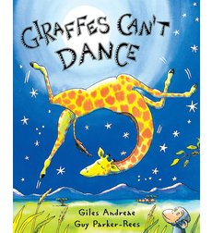

Kristin Giorgio
July18, 2016
EDU 571
Communication Disorders

Lesson Plan: “Giraffes Can’t Dance”
Title and Author:
“Giraffes Can’t Dance,” by: Giles Andreae
Grade: Kindergarten
Reading Level: 2.5 Guided Reading Level: M | Lexile Level: AD450L Type of Book: Read aloud book
Key Understanding: This story is about Gerald, a friendly, yet clumsy giraffe. After Gerald is humiliated at the Jungle Dance, he meets a wise, cricket who teaches him to discover his own unique and wonderful moves. Gerald dances triumphantly at the end. Gerald is a great example of finding one’s own way to do what feels impossible.
Suggested number of days: 3 Common Core ELA Standards:
CCSS.ELA-LITERACY.RL.K.1
With prompting and support, ask and answer questions about key details in a text.
CCSS.ELA-LITERACY.RL.K.2
With prompting and support, retell familiar stories, including key details.
CCSS.ELA-LITERACY.RL.K.3
With prompting and support, identify characters, settings, and major events in a story.
CCSS.ELA-LITERACY.RL.K.4
Ask and answer questions about unknown words in a text.
IEP Goals lesson addresses:
Goal 1: After being read a story the student will be able to retell the elements of the text in logical sequence, receiving 80% accuracy by getting 3 out of 4 on the Teacher created Retell/ Sequence Rubric.
Goal 2:
After being read a story the student will be able to retell the elements of the text in logical sequence, receiving 80% accuracy by getting 3 out of 4 on the Teacher created Comprehension Rubric.

Reading Comprehension Rubric:
Retell/ Sequence | Tells 1 or 2 events or key facts | 2 Tells some of the events or key facts | 3 Tells many events, in sequence for the most part, or tells many key facts | 4 Tells most events in sequence or tells most key facts
Comprehension | Provides limited or no response to teacher questions and prompts | 2 Provides some response to teacher questions and prompts | 3 Provides adequate response to teacher questions and prompts | 4 Provides insightful response to teacher questions or prompts

Baselines
Student | Vocabulary | Story Grammar/Comprehension | Written Language
Andrew Justice | Student understands  Tier I and some Tier II vocabulary. | The student was able to remember the sequence of events by being asked simple questions, and with use of pictures: Why was Gerald sad at the beginning of the story? Why was Gerald happy at the end of the story? When kept on task the student was able to identify characters and other things throughout the book. | No written language sample.  Was able to put story sequence cards in order with captions.

Materials:
- Book: “Giraffes Can’t Dance,” by: Giles Andreae
- Vocabulary word cards with pictures and definitions
- Songs for students to dance to on CD or iPod: “The Twist,” “The Chicken,” and “Alley Cat”, All-Time Favorite Dances. (1995).
- Animal hats, animal costumes, and decorations for dramatic play.
- Animal mask craft
- Cut and Paste Story sequence handout

Before Reading
Cultural Supports, Building Background
Learn about geography- continents.
Where different animals live.
Learn about different instruments and music.
Learn about the geography and culture of Africa.
Learn about different feelings and emotions.
Learning about differences.
Connecting Activity: (Questions, Conversation about topic):
The class has been learning about the world and the different continents, including Africa. We have discussed where we live in relation to Africa and to other places around the world, while studying our Geography Unit. Students have studied about the various animals that live on different continents including Africa. The class has also been learning about differences and how people should try things even though sometimes it might seem to hard or difficult.
Genre Set-Up, Bridging Conversation, Think-Aloud, Setting Purpose
(What strategy are you highlighting in your lesson)
The purpose of reading this story is to understand that it is okay to be different and dance to the beat of our own drum. The strategy that is highlighted in the lesson is questioning.

Vocabulary
Word | Contextualize Word  In the story….. | Definition  ( kid friendly) | Example beyond story | Bridge to story  Picture
Elegant | “The lions danced a tango that was elegant and bold.” | beautiful, attractive, graceful | The princess’s dress was elegant. | 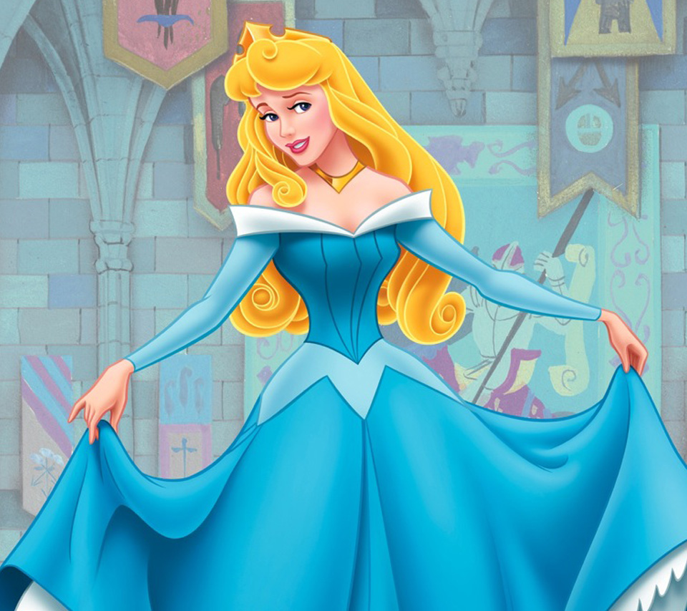
Splendid | “... and eight baboons then teamed up for a splendid Scottish reel.” | wonderful, fabulous | It was a splendid idea to eat lunch at McDonalds.
Shuffled | “His hooves started “shuffling, making circles on the ground.” | walk by dragging one's feet along or without lifting them fully from the ground | The boy shuffled his feet to bed. | 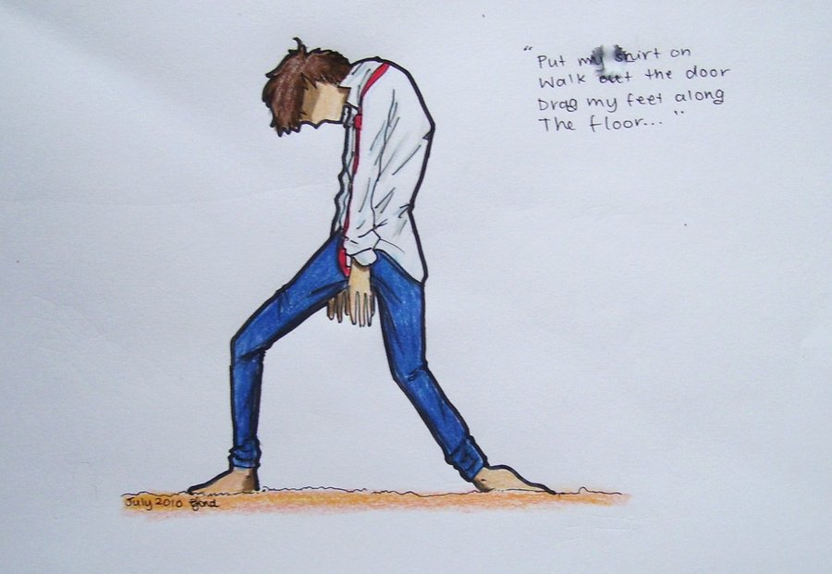
Sneered | “Hey, look at clumsy Gerald, the animals all sneered.” | to have a mean look on your face. | The girl sneered at the mean boy.
Waltzing | “The warthogs started waltzing…” | ballroom dancing | The princess and prince were waltzing at the ball. | 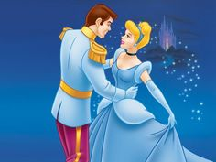

Comprehension Strategy

Before Reading
Make a connection | Make inferences | Prediction
Self-Monitor | Prior Knowledge | Questioning
Identify Important Information | Visualize | Synthesis

Comprehension Strategy | Language (What you say to support, teach the comprehension strategy)
Prediction/ Questioning  Prior Knowledge  (Look at a map and review where Africa is, and talk about some of the animals that live there.) | The teacher will have my students look at the front cover of the story.  The teacher will ask “Tell me what you see.”  “Why do you think it is called Giraffes Can’t Dance?”  “What do you think the story is about?”  “What kind of animals do you see?”  “Where do you think the story takes place?”  After reviewing the cover, the teacher will introduce the text and explain to the students, “Today we are going to read you a book called “Giraffes Can’t Dance”. It is about a giraffe named Gerald, who is very bad at dancing. The teacher will explain that Gerald lives in Africa, and that a Jungle Dance is held where he lives every year. The teacher will then read aloud the entire story. During the reading, the teacher will explicitly teach the Tier II vocabulary words; elegant, splendid, shuffled, sneered, and waltzing.

During Reading
Make a connection | Make inferences | Prediction
Self-Monitor | Prior Knowledge | Questioning
Identify Important Information | Visualize | Synthesis

Post It # | Comprehension or Vocabulary | Language you will use to teach, focus or probe for understanding
p.2 | Identify Important Information | After reading the first page, the teacher will ask the students, What is the giraffe’s name in the story?
p.6 | Make a Connection (feelings) | Why do you think Gerald felt so sad when the day of the Jungle Dance arrived?
p.7 | Questioning  Vocabulary | “The warthogs started waltzing and the rhinos rock‘n’rolled.” What were the warthogs doing?
p.8 | Questioning  Vocabulary | “The lions danced a tango that was elegant and bold.” What does it mean to be elegant?
p.10 | Questioning  Vocabulary | The eight baboons teamed up for a splendid Scottish reel. What does splendid mean?
p.11-14 | Identify Important Information/ Make a Connection | Why do you think Gerald froze and ended up leaving the dance floor to walk home? Why was he so sad? Why did he agree with the others who laughed at him, and called him weird and a silly fool?
p. 12 | Visualize | “...the animals all sneered.” Why did the animals sneer at Gerald?
p.16 | Prediction | “But sometimes when you’re different you just need a different song.” What do you think is going to happen when Gerald hears a new song?
p.19 | Questioning  Vocabulary | What happened when Geralds hooves started shuffling?”
p.24 | Make a Connection | Why did Gerald feel so wonderful when he realized he was dancing?

After Reading

Comprehension Questions

Bloom Taxonomy  Question Type | Question: Have a mix of questions
Knowledge | Who was the main character?
Comprehension | Where does the story take place? (Setting)
Application | Describe the problem. (Plot)
Analysis | How does Gerald feel at the end of the story, compared to in the middle when the animals were laughing at him?
Synthesis | What would you do if you were Gerald?
Evaluation | When have you felt like Gerald - wanting to do something that EVERYONE else could do and you weren’t very good at it?

Culminating Writing Task

Teacher directions and activities to prepare students for writing:
Students will be asked to write about something that they have worried about like Gerald and about something that they feel that they do well.
Prompt:
I am like Gerald the giraffe when I worry about __________________________. I am good at __________________________.

Differentiation Options (modify by content, process, and/or final product)

English Language Learners (ELL)/ Language learner disabilities | Pre-teach difficult vocabulary and concepts  Manipulatives/ Pictures  Sentence strips  Picture Walk  Sequence Cards  Feelings chart with captions  Have students act out parts of the story (include movement).

Any visuals or other supporting documents that you feel support this lesson.

- Masks of the animals
- Sequence cards
- Feeling pictures

