Title and Author:
A Pocket for Corduroy Dan Freeman
Grade:
3rd Grade (Severe/Profound Self Contained Classroom)
Reading Level: Guided Reading Level K | Lexile Level: 600
Key Understanding: Corduroy has to overcome many challenges in order to get a pocket.

Suggested number of days: _____3______Common Core ELA Standards:
CCSS.ELA-LITERACY.RL.3.1
Ask and answer questions to demonstrate understanding of a text, referring explicitly to the text as the basis for the answers.
CCSS.ELA-LITERACY.RL.3.2
Recount stories, including fables, folktales, and myths from diverse cultures; determine the central message, lesson, or moral and explain how it is conveyed through key details in the text

IEP Goals lesson addresses:
Goal 1: After being read a story at his read aloud level, Darian will be able to give a retell that includes the beginning, one detail from the middle, and the ending of the story with 80% accuracy as measured by observation and language sample of his retelling
Goal 2: After being read a story, Darian will be able to answer questions about the characters, setting and the events of the story by matching up pictures of characters, the setting in the story and identifying key details through pictures with 80% accuracy as measured by teacher records and observations.
Goal 3: Student will be able to accurately answer questions throughout the reading with 80% accuracy as measured by teacher records and observations
Goal 4: Student will complete thirty-minute tasks with only 5 given prompts to stay on task.

Baselines
Student | Vocabulary | Story Grammar/Comprehension | Written Language
Darian | Kindergarten vocabulary  Extremely Low range for grade level | Tier 1 words, tier two with support  Can name characters, Listening Comprehension | Unable to Write, Student still practices tracing his name  Extremely Low range for grade level

Materials:

- A Pocket for Corduroy (book)
- Vocabulary Cards
- Chrome book,
- Board maker item sort activity
- Boardmaker color sort activity
- YouTube video of 8 year old explaining how to do laundry
- Pictures of Laundromat,
- Glue
- Scissors
- Before reading worksheet
- During Reading Questions
- After reading activity
- IPhone to record language sample

Before Reading
Cultural Supports, Building Background
- The teacher will show the student pictures of a Laundromat. Teacher will explain a Laundromat is a place where people clean their clothes. The teacher will explain to the student what a washer and dryer is and what they do. The teacher will explain what laundry detergent and dryer sheets are, how people pay to use each machine in quarters (some places credit cards) and how Laundromats are more frequently used in cities.
- The teacher will have the student complete the Boardmaker sorting activity where the student will have to sort whether an item goes into the washer, kitchen or toy chest.
- The teacher will then explain how people need to sort their clothes by color; student will complete a color sort activity on Boardmaker. Student needs to drag and sort items by color for this activity.
Connecting Activity: (Questions, Conversation about topic):

- The teacher will show a YouTube video where an 8 year old explains how to do laundry:
- https://www.youtube.com/watch?v=lDcB8buur9w, the teacher will stop and pause the video to further explain the aspects being shown in the video
- After watching the video the teacher will have the student complete a worksheet where they will glue a picture relating to a Laundromat, next to their description:
- For example: A machine that uses water and soap to wash your clothes would be the description listed and the student will have to choose between a picture of a washer or dryer to glue in

Genre Set-Up, Bridging Conversation, Think-Aloud, Setting Purpose
(What strategy are you highlighting in your lesson)
- I will have the student preview the text, and stop and talk about the different descriptions and pictures that relate to a Laundromat. The purpose of this activity is for the student to understand the setting of the book is a Laundromat and how the setting affects what happens in the story.

Vocabulary
Word | Contextualize Word  In the story… | Definition  (Kid friendly) | Example beyond story | Bridge to story  Picture
Laundromat | Pg.1 “Late one afternoon Lisa and her mother took their Laundry to a Laundromat.” | A place where you wash your clothes | My washing machine broke at home and now we have to go to the Laundromat to wash my clothes | 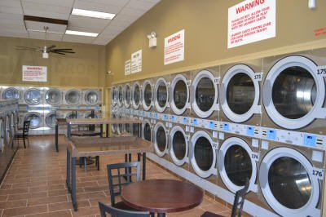
Patiently | Pg.4 “Corduroy waited patiently.” | To wait quietly | You need to wait patiently in line to go to recess | 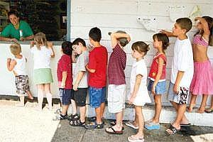
Precious | Pg. 5“You don’t want your precious things to get all wet and soapy.” | Something that is important to you | I don’t want to lose my precious trucks at recess. | 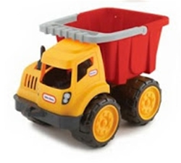
Pocket | Pg. 6 “Be sure to take everything out of your pockets Lisa dear.” | A pouch you put thing in, on jeans or shirts | Put your money in your pocket, so you don’t lose it. | 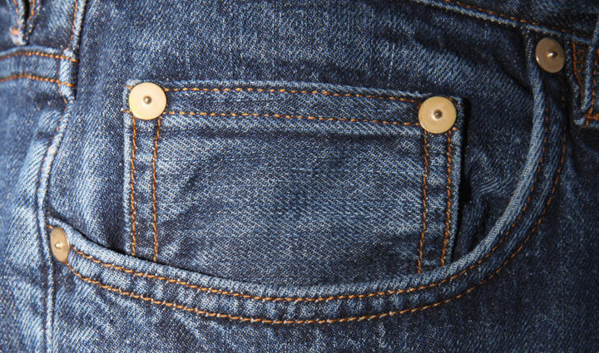
Dampness | Pg. 10 “ Without hesitating, he climbed inside the bag, which was filled with pieces of wet laundry. The dampness didn’t bother Corduroy in the least.” | Wetness | After water play my towel gets damp. | 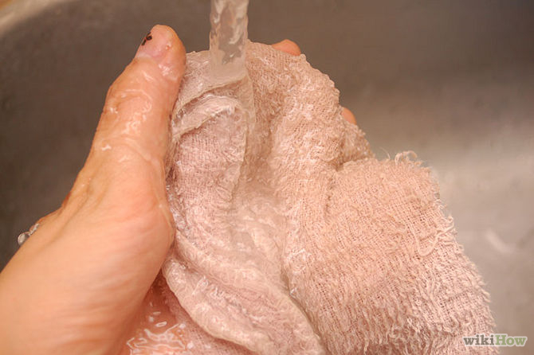
Whirling | Pg. 17 “Finally the dryer stopped whirling and the man gathered up the clothes.” | Spinning | Look at the whirling top. | 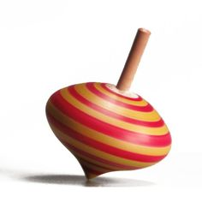
Gathered | Pg. 17 “Finally the dryer stopped whirling and the man gathered up the clothes.” | Collect | He gathered up his Pokémon cards. | 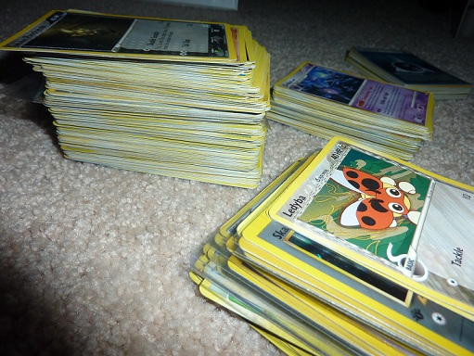

Customer | Pg. 24 “ My customers are always leaving things.” | A person who buys something | When I was a customer at dairy queen I asked for sprinkles and Chocolate sauce.

Comprehension Strategy

Before Reading
Make a connection | Make inferences | Prediction
Self Monitor | Prior Knowledge | Questioning
Identify Important Information | Visualize | Synthesis

Comprehension Strategy | Language (What you say to support, teach the comprehension strategy)
Prediction  Prior Knowledge  Visualize | “What does the title of the book make you think its going to be about.”  “Let’s look at the pictures before we read the story”  “What do you see?”  “Who do you think is in this picture?”  “Where is the story taking place?”  “How can you tell?”  “What do you think will happen next?”  “What do you think happens in the end?”  I will ask the student what he knows about a Laundromat. What does someone do there?  The teacher will then read aloud the entire story, A Pocket for Corduroy.  During the reading, the teacher will explicitly teach the vocabulary words Laundromat, patiently, precious, Pocket, dampness, whirling, gathered, and customer.  The teacher will review the Tier II words while reading. These words were discussed using vocabulary cards.

During Reading
Make a connection | Make inferences | Prediction
Self Monitor | Prior Knowledge | Questioning
Identify Important Information | Visualize | Synthesis

Comprehension or Vocabulary | Language you will use to teach, focus or probe for understanding | Post It #
Comprehension Strategy: identify important information
 | After reading the first page, I will ask Darian: What is the girls’ name? What is corduroy? And Where are they going? | Pg. 1
Visualize/make a connection | The teacher will have the student focus on the picture and ask How do you know the Laundromat is busy? | Pg.2
Questioning | What does Lisa tell Corduroy to do? | Pg.3
Make inferences | What does Lisa’s mom want her to empty out her pockets? What she is afraid could happen if she forgets something in her pocket and it goes in the washer? | Pg.5
Questioning | What does corduroy not have? Why does he leave the chair? | Pg. 7
Questioning | What does corduroy climb into? What does he think it is? Why does he think it is a cave? | Pg.10
Identify important information | Where did corduroy go? Why does Lisa have to leave the Laundromat? Why does she leave without Corduroy? Does she seem happy or upset to leave without Corduroy? | Pg.11
Make inferences/ Prediction | Before reading the page: Stop and ask the student, Why is Corduroy in that man’s laundry? What did he climb into earlier? Do you think the man will find Corduroy in his laundry? | Pg.12
Questioning | Does Corduroy end up in the washing machine? Why not? | Pg.13
Questioning | Why did the man take Corduroy’s clothes? | Pg.13
Questioning: | Why does the man draw a picture of his clothes in the washing machine? What is he? | Pg.14
Questioning: | Did Corduroy get his clothes back? | Pg.15
Prediction | After the man left, what do you think corduroy is going to do all night by himself? | Pg.16
Visualize | Look at the picture, What is Corduroy really playing with? Is it snow? If not, what is it? Why does he think it is snow? | Pg.19
Visualize/Make a connection | What does corduroy fall into? Why does he think it is a cage? Have you ever sat or played with a laundry basket when you were little? | Pg.20
Questioning | What does Corduroy do in the cage? | Pg.21
Visualize | How do we know it is no longer nighttime? | Pg. 21
Questioning | Who comes back? Why did she come back? | Pg.21
Questioning | Who finds Corduroy? | Pg.22
Identify important information | Corduroy is Lisa’s what? And he is also her? | Pg.23
Identify important information | Why did Corduroy not wait for Lisa? What was he looking for? What does he want? | Pg.24
Questioning: | What is an affectionate squeeze? What is an affectionate squeeze similar to? | Pg.24
Prediction | After reading the page and asking the above questions, the teacher will ask the student if they think that Corduroy will ever get a pocket? | Pg.24
Identify important information | What was Corduroy looking for in the story? Did he get a pocket? Who made him a pocket? | Pg.25
Synthesis | After finishing reading the story the teacher will ask the student how they think Corduroy feels after finally getting a pocket? What do you think he would have done had Lisa not made him a pocket? Do you think he would have kept looking or given up? | Pg.25

After Reading

Comprehension Questions

Bloom Taxonomy  Question Type | Question: Have a mix of questions
Knowledge | What is the setting of the story?  Who is the story about?
Comprehension | What was it that Corduroy looking for?  What happened after Corduroy left his chair to look for a pocket?  What happened after the artist left Corduroy alone overnight in the Laundromat?  What happened the next day at the Laundromat?  What happened when Lisa found out Corduroy wanted a pocket?
Application | What would you have done if a store was closing and your favorite teddy bear was missing inside the store?
Analysis | Do you think Lisa loves Corduroy? Why?
Synthesis | What events lead to the Corduroy getting a pocket?
Evaluation | Do you think Lisa and Corduroy were happy to be back together? Why or why not?

Culminating Writing Task

Teacher directions and activities to prepare students for writing
Student complete an after reading worksheet
Student will decorate his own Pocket for Corduroy
Prompt: Students will answer Comprehension questions related to the story and answer them by gluing the correct picture to match the question
Questions include:
- What is Corduroy? (Answer: picture of a teddy bear)
- Who is Corduroy’s friend? (Answer: picture of Lisa)
- Where did Corduroy get left? (Answer: picture of Laundromat)
- What was Corduroy looking for? (Answer: picture of pocket)
- What does Corduroy climb into? (Answer: picture of basket)
- Who found Corduroy in his clothes? (Answer: picture of artist)
- What did Corduroy knock over at night? (Answer: picture of laundry detergent)
- What did Lisa make Corduroy when she found him? (Answer: picture of Lisa giving corduroy a pocket)

Prompt: Student will color in and decorate his own Pocket for Corduroy
Student will be given a white pocket for corduroy to color in and decorate. Student will be able to use markers. Student is instructed to stay in the lines, use more than three colors and take their time.

Scoring notes or Sample response: informal assessment - check to see if they match the pictures correctly with the questions
Student will decorate a pocket for corduroy scoring:
Informal assessment: Check to see if student followed directions. Used more than three colors and stayed in the lines.

Differentiation Options (modify by content, process, and/or final product)

English Language Learners (ELL) | Model and focus on specific language in the story. Focus on what a Laundromat is, identify that Corduroy is the name of the bear and Lisa is his friend and are both main characters in the story. Explain how Corduroy is looking for a pocket because he doesn’t have one. Explain how the cave in the story is a laundry basket, and the snow is laundry detergent. Explain words, and topics ELL student may not be familiar with. Build background knowledge by using pictures, videos, real objects, and personal experiences. Show pictures of a Laundromat and explain what it is, show a video of someone doing laundry at a Laundromat. Ask the student if the know what a pocket is and show you if they have one. Explain to a student what overalls are, the different objects at a Laundromat: washer, dryer, basket, clothes, clothes hangers, laundry bags, laundry detergent, what people wash there.  Have student listen to the book at tape, provide visual aids such as a labeled diagram of a Laundromat, have hands on manipulative such as laundry detergent, laundry bag. Allow student to first read the Spanish version of the book A Pocket for Corduroy, allow them to listen to Spanish audiotape of book reading.
Language learner disabilities | Allow student to listen to, A Pocket for Corduroy audiobook and follow along with a physical copy of A Pocket for Corduroy. Explain what a Laundromat is, allow them to watch a video of a Laundromat. Explain the different parts of a Laundromat such as: Washer, dryer, basket, clothes, clothes hangers, laundry bags, and laundry detergent using visuals.  Use Boardmaker activities that involve a Laundromat such as sorting items based on whether they belong in a toy chest, Laundromat, or in a kitchen.  Modify and simplify the questions to enable the students to recall the parts of the story.  Teacher will ask questions that require short responses, For example:  What is the bear’s name?  What is the bear looking for?  What is Corduroy’s friend’s name?  What three things happen to Corduroy after Lisa leaves him at the Laundromat?  Why did the artist take off corduroy’s close?  Does Lisa find Corduroy?  Does Corduroy get a pocket?  Who made Corduroy a Pocket?  Allow students to answer questions using pictures.

Any visuals or other supporting documents that you feel support this lesson.

YouTube video where an 8 year old explains how to do laundry: https://www.youtube.com/watch?v=lDcB8buur9w
Boardmaker- Color Sort and item sorting activity
Have student watch movie A pocket for Corduroy

Extension literacy Activities:
First reading Corduroy, to get introduced to this character first, use a Venn diagram to compare and contrast Corduroy to A Pocket for Corduroy

Home School Connection
- Send home a retelling activity to reinforce literacy skills at home.
The teacher will send home a modified text and visuals in order to retell the story such as A pocket for Corduroy for Corduroy book in Spanish.
The teacher will ask parents to read this story to the student in their native language if Spanish. If native language is not Spanish teacher will try to find a copy of the book in their home/ native language.

- The teacher will send home a list of Tier II vocabulary words that we will be learning.
I will send home vocabulary cards and ask the parents to practice them with their students playing a matching game. The students must match the vocabulary card to the picture that visually represents the Tier II vocabulary word.

