Title and Author:
Chapter 31. To Kill A Mockingbird. By Harper Lee.
Grade:
8
Reading Level: ages 12-17 | Lexile Level: 790L
Key Understanding:
- Students will understand how the view of Boo Radley in the novel shows prejudice and that you should not form an opinion on someone until you’ve met and spent time with them.

Suggested number of days: 3 Common Core ELA Standards:
CCSS.ELA-LITERACY.RL.8.4
Determine the meaning of words and phrases as they are used in a text, including figurative and connotative meanings; analyze the impact of specific word choices on meaning and tone, including analogies or allusions to other texts.
CCSS.ELA-LITERACY.RL.8.1
Cite the textual evidence that most strongly supports an analysis of what the text says explicitly as well as inferences drawn from the text.

IEP Goals lesson addresses:
Reading Goal: By June, Kasey will improve his listening comprehension by scoring a 3 out of 4 on the Listening Comprehension rubric for 4 grade level readings.

Writing Goal- By June, Kasey will write a 5 paragraph essay where he will write complete sentences that are grammatically correct. He will score a 3, or Developing, on the 6 +1 Traits Writing Rubric in sentence fluency. He will also support his ideas in the 5 paragraph essay, scoring a 3, or Developing, on the 6 +1 Traits Writing Rubric in Ideas.

Baselines: If scores are not available to you create a sample score that a student might have.
Student | Vocabulary | Story Grammar/Comprehension | Written Language
Kasey | Average | Below Average | Low

Materials:

- To Kill A Mockingbird chapter 29-30 photocopy for student
- Bias Worksheets
- Vocabulary worksheets
- Close Reading directions worksheet.
- Computer
- Wifi
- Video Clips
- Highlighters
- dictionary
- Character Chart worksheet.
- Graphic Organizers
- 6+1 Writing Traits Rubrics: http://educationnorthwest.org/sites/default/files/new-rubrics-3-12.pdf

Before Reading
Cultural Supports, Building Background
- Do an activity on Prejudice.
  - See Bias worksheets
  - Student will read 4 scenarios and discuss with the student what is going on in the scenario
  - Have students think about how each scenario would make the person being discriminated against feel and then what they would do to prevent the discrimination from continuing.
  - Fill out the chart

- Watch video clip: http://www.tcm.com/mediaroom/video/332425/To-Kill-A-Mockingbird-Movie-Clip-A-Maniac-Lives-There.html
  - Video clip will allow the students to understand the prejudice the town has towards Boo Radley prior to Scout meeting him.
  - VIdeo clip builds background knowledge the student needs to understand the importance of the moment Scout meets Boo Radley.
Connecting Activity: (Questions, Conversation about topic):

What is prejudice and what are the effects of prejudice? What makes a hero?

Genre Set-Up, Bridging Conversation, Think-Aloud, Setting Purpose
(What strategy are you highlighting in your lesson)

We will be focusing on vocabulary and comprehension in this lesson. Students will use the Close Reading model as they read. Go over the Close Reading directions with the student. Go over the vocabulary charts with the student as well. See attached vocabulary worksheets.

Students will also complete a spelling word chart. They will use these words in their writing whenever possible for bonus points.

Before reading, Students will complete the first column on the character chart on Boo Radley. See attached character chart worksheet.

Vocabulary
Word | Contextualize Word  In the story….. | Definition  ( kid friendly) | Example beyond story | Bridge to story  Picture
Hover | “Boo’s hand hovered over Jem’s head” pg 372 | remain in one place in the air | When a bee pollinates a flower, they hover over the flower | 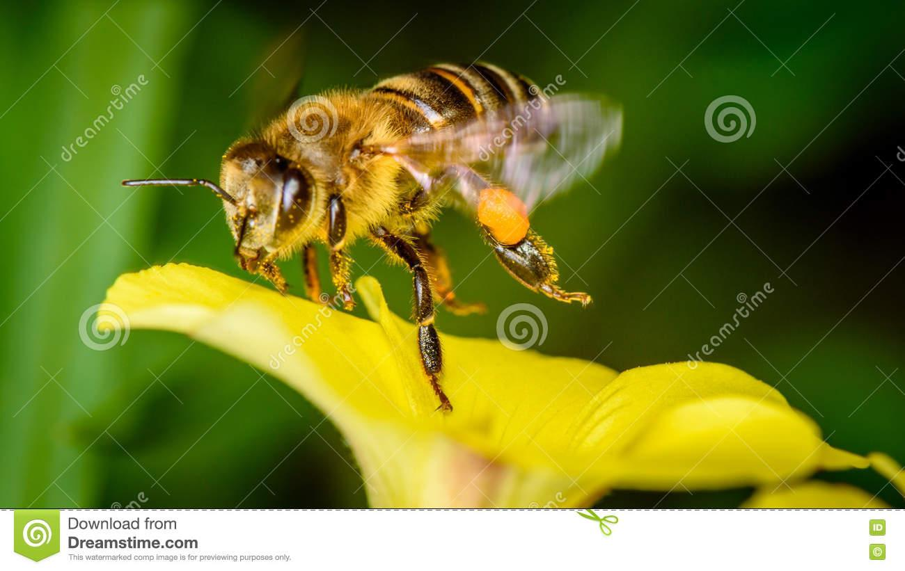
accommodate | “He had to stoop a little to accommodate me…” pg 372 | arrangement | When you go to a restaurant and tell them your party number, they pick a table to accommodate the number of people in your group.
apprehensive | “They stopped at an oak tree, delighted, puzzled, apprehensive.” Pg 374 | fearful that something bad will happen | When going to the dentist, I am always apprehensive.
amiable | “I was puzzled by his amiable acquiescence.” Pg 375 | friendly | The puppy was amiable. | 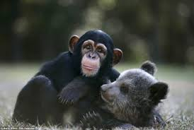
Acquiescence | “I was puzzled by his amiable acquiescence.” Pg 375 | acceptance, allowing | The teacher’s acquiescence to fidget spinners was appreciated by the students.

Comprehension Strategy

Before Reading : What is the strategy that you are using to help the child understand the text? These are some examples.
Make a connection | Make inferences | Prediction
Self Monitor | Prior Knowledge | Questioning
Identify Important Information | Visualize | Synthesis

Comprehension Strategy | Language ( What you say to support, teach the comprehension strategy)
Making a Connection/Prior Knowledge  Identify Important Information | - Ask the student if they ever felt judged or that people assumed something about them before getting to know them. Have a brief discussion on this to build prior knowledge of discrimination and prejudice.  - Introduce the video clip of “A Maniac Lives There” to go over how the town views Boo Radley by telling the students to play close attention to how Boo Radley is described in the video clip. Explain to them that this view of Boo Radley is the town using stories about Boo to build a prejudice against him. Explain that the children in the clip have never met Boo Radley and are listening to the town gossip instead to judge him. Have them jot notes down while they watch the video clip in the first column of the Character Chart.

During Reading : What is the strategy that you are using to help the child understand the text? These are some examples
Make a connection | Make inferences | Prediction
Self Monitor | Prior Knowledge | Questioning
Identify Important Information | Visualize | Synthesis

Page # | Comprehension or Vocabulary | Language you will use to teach, focus or probe for understanding
372 | “I was beginning to learn his body English” | Ask students what they think is meant by “body English”. Have a discussion on what body language is and why it is important to read people’s body language. How can we learn more about a person based on their body language?
373 | Scampered | using context clues, how can we determine what scampered means? “two children scampered down the sidewalk”
375 | “I was puzzled by his amiable acquiescence” | Mock think aloud for this sentence. Explain that these are two unfamiliar words in a row for you. Tell them you will write them on your vocab chart to look up the words. First try to see if there are context clues. Since there are not context clues, use a dictionary to look up the two words, write a brief definition down, and then reread the sentence replacing it with known words to make sure you understand the sentence now.
376 | “Most people are, Scout, when you finally see them” | Discuss with the student the meaning of this quote. Check for understanding of the quote. Explain how prejudice is when you don’t really see a person. To fight it, you have to really see them.

After Reading

Comprehension Questions

Bloom Taxonomy  Question Type | Question: Have a mix of questions
Knowledge | What was Boo Radley’s real name?  What did Boo Radley give Jem and Scout?  What did Jem and Scout give Boo Radley?
Comprehension | How did this chapter’s version of Boo Radley differ from the description given in video about the him?  Why does Scout say Jem will be so made when he wakes up?
Application | Have you ever judged someone and then got to know them and realized you were wrong?  When in history have people judged others wrongfully?
Analysis | What did Atticus mean by “you never really know a man until you stand in his shoes and walk around in them?  How did Scout’s prejudice change in this chapter?
Synthesis | Write about your feelings towards Boo Radley after reading this chapter.  In the future, how will the two of them remember the actions of Boo Radley?
Evaluation | In your opinion, is prejudice something we still battle with in today’s world?  What rules/lessons does this chapter offer in our world today?

Culminating Writing Task

Teacher directions and activities to prepare students for writing
- Use graphic organizers to help students organize their thoughts
  - First have students brainstorm on the brainstorming worksheet why they should not judge people.
  - Hand out the evidence worksheet
    - Have students look back into the chapter to find evidence. Help them find evidence by writing page numbers and quotes or paraphrased information from the novel.
  - Complete the essay outline.

Prompt: Why is it important not judge a person based on gossip and assumptions? Give three reasons why and think of how this chapter show this importance? Include evidence.
Scoring notes or Sample response:
Use the 6+1 Traits Writing Rubric for Word Choice and Ideas. Grade them based on those two rubrics. Combine the two scores and divide by two to get an overall score.
Sentences should be based off grade level and student ability.

Differentiation Options (modify by content, process, and/or final product)

English Language Learners (ELL) | -Read Aloud  -Oral assessment- Student can verbally answer questions with teacher writing answers down. Student can then rewrite their answers in their own handwriting to practice spelling and writing skills  -Students can draw pictures in place of written responses when applicable.
Language learner disabilities | -Read Aloud  -Oral assessment- Student can verbally answer questions with teacher writing answers down. Student can then rewrite their answers in their own handwriting to practice spelling and writing skills  -Students can draw pictures in place of written responses when applicable.  -once read out loud, watch video clip from movie: https://www.youtube.com/watch?v=iRmIef02Ajk

Any visuals or other supporting documents that support this lesson are below

Name:______________________________________ Date:____________________

To Kill A Mockingbird Vocabulary Chart

As you read the book, look for words you don’t recognize and write them in the chart. Then you will define each word and draw a picture that reminds you of the definition of the word.
Vocabulary Word | Definition | Picture
Name: ___________________________________________ Date: _________________

Character Chart: Boo Radley

How do characters in the novel describe Boo Radley in the video clip “A manic lives there” | In chapters 29-30, what do you learn about Boo Radley’s character? | How do you think meeting Boo Radley changes how Scout sees Boo Radley now?

Bias scenarios
1.  A young girl wants to join the swim team, but is told by the coach she doesn't have the strength to swim long distances. He says, "Why don’t you go home and play with your Barbie instead?" | 2.  A teenage boy decides to learn Jazz Dance. When he arrives at the dance school, the teacher laughs and says, "Why aren't you playing soccer?"
3.  A girl tells her friend how her father looks after her baby sister at home while her mother works. Her friend raises her eyebrows and says, "That's weird! Dads aren't supposed to look after babies - mums should!" | 4.  A Greek-Australian girl is not invited to a birthday slumber party. Her friend says, "My mum said Greeks don't allow their children to go to slumber parties."

Scenario | How would the person being discriminated against feel in the scenario. Draw or write your answer. | How would you help in this situation to prevent the discrimination from going any further. Draw a picture or write your answer.
1
2
3
4

Name: ________________________________________________________ Date: ___________________________________

Using the web below, Brainstorm why judging people is bad.

Why is it important to not judge other people? Why is making assumptions bad.

Name: ________________________________________________________________ Date: _______________________

Evidence Graphic Organizer:
Use this to locate evidence in the text. Fill in each column.

Page Number | Quote/Paraphrased section | Meaning

Name:______________________________________________________ Date: ______________________

Graphic Organizer: Writing Sample

Prompt: Why is it important not judge a person based on gossip and assumptions? Give three reasons why and think of how this chapter show this importance? Include evidence.

Reason 1: | Reason 2: | Reason 3:
Supporting Details and Evidence | Supporting Details and Evidence | Supporting Details and Evidence
Name: ________________________________________________________________ Date: ________________________

Comprehension Questions. Answer these following the reading of the chapter:

- What was Boo Radley’s real name?

- What did Boo Radley give Jem and Scout?

- What did Jem and Scout give Boo Radley?

- How did this chapter’s version of Boo Radley differ from the description given in video about the him?

- Why does Scout say Jem will be so made when he wakes up?

- Have you ever judged someone and then got to know them and realized you were wrong?

- When in history have people judged others wrongfully?

- What did Atticus mean by “you never really know a man until you stand in his shoes and walk around in them?

- How did Scout’s prejudice change in this chapter?

- Write about your feelings towards Boo Radley after reading this chapter.

- In the future, how will the two of them remember the actions of Boo Radley?

- In your opinion, is prejudice something we still battle with in today’s world?

- What rules/lessons does this chapter offer in our world today?

