Title and Author: Dear Mrs. Larue
Lesson Plan: Jay Sawin

Grade: 3rd Grade
Reading Level: 2nd Grade | Lexile Level: 730L
Key Understanding:
- The student will learn that there are two point of views to every story.
- The student will learn and reflect on misunderstandings from the story and their own life.
- The student will learn that Ike’s perspective is different from reality.
- The student will learn a strategy to document key ideas from the text.
Suggested number of days: 2 - 3
Common Core ELA Standards:
Reading: Reading: Literature
Key Ideas and Details
CCSS.ELA-LITERACY.RL.3.1
Ask and answer questions to demonstrate understanding of a text, referring explicitly to the text as the basis for the answers.
CCSS.ELA-LITERACY.RL.3.2
Recount stories, including fables, folktales, and myths from diverse cultures; determine the central message, lesson, or moral and explain how it is conveyed through key details in the text.
CCSS.ELA-LITERACY.RL.3.3
Describe characters in a story (e.g., their traits, motivations, or feelings) and explain how their actions contribute to the sequence of events.
Craft and Structure
CCSS.ELA-LITERACY.RL.3.6
Distinguish their own point of view from that of the narrator or those of the characters
Integration of Knowledge and Ideas
CCSS.ELA-LITERACY.RL.3.7
Explain how specific aspects of a text's illustrations contribute to what is conveyed by the words in a story (e.g., create mood, emphasize aspects of a character or setting)
Reading: Foundational Skills
Fluency
CCSS.ELA-LITERACY.RF.3.4.A
Read grade-level text with purpose and understanding.
IEP Goals lesson addresses:
By August, the student will increase an understanding of tier two vocabulary words shown through using 4 out of 5 tier two words correctly through a written response to Dear Mrs. Larue.

Baselines: If scores are not available to you create a sample score that a student might have.
Student | Vocabulary | Story Grammar/Comprehension | Written Language
Emily H. | Misunderstood | Confusion about the word when asked ahead of time. It is a central word to the text. Also found in the book numerous times. | Student does not enjoy writing, struggles with putting ideas on paper.

Materials:

-https://www.youtube.com/watch?v=x6D8PAGelN8- Youtube video detailing fantasy vs. reality. This will explain how the story is written, going back and forth between Ike’s perception vs. reality.

-Who Misunderstood? - Graphic organizer during reading that will help distinguish between the two stories and help the student come to a conclusion at the end about what is real and not real.

-Writing the right letter- Writing a letter to Mrs. Larue where Ike is honest about his mistakes. Incorporates vocabulary words using a word bank.

-Pencil

-Dear Mrs. Larue story

Before Reading
Cultural Supports, Building Background:
The teacher will show a clip from the Wizard of Oz where Dorothy gets brought to Oz. The scene transfers from normal life to Oz in color.
The teacher will ask observational questions related to the video. The student will discuss the two points of view and the differences between them.
Connecting Activity: (Questions, Conversation about topic):
The teacher will ask the student, what are some examples of good and bad behaviors of dogs?
The teacher will read the inside cover of the book, which details how the story is told.
Genre Set-Up, Bridging Conversation, Think-Aloud, Setting Purpose
(What strategy are you highlighting in your lesson)

The teacher would like the student to learn to decipher reality from imaginary when hearing two sides to the story Dear Mrs. Larue.

Vocabulary
Word | Contextualize Word  In the story….. | Definition  ( kid friendly) | Example beyond story | Bridge to story  Picture
Misunderstood | “Your misunderstood friend...”  Ike is explaining how he is not a bad dog, but misunderstood. He explains this throughout the story through his perception vs. reality. | To fail to understand  OR  To interpret incorrectly | Writing something down that may mean different things. When people read it, they may interpret it differently. Giving directions that may be confusing to the people receiving them. | 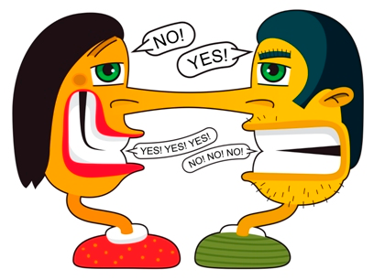
Complain | “I must say you weren’t very grateful, complaining on and on about the tiny rip in your ratty old coat.“  Ike states that Mrs. Larue is the one complaining, when in actuality, he is the one complaining. | to express grief, pain, or discontent  find fault  to accuse someone of wrongdoing | People complain about the weather when it is bad. There are sometimes even more complaints about the weatherman on the news.  When Teddy(my dog) has accidents in the house or barks at people who are walking by. Sometimes they complain, most of the time I do.
Howl | “First, I didn’t howl that much.”  Ike talking about one of the reasons he was sent to obedience school. | a long, loud, cry uttered by an animal such as a dog or wolf | Late at night, we can hear wolves and coyotes howling at the moon.
Appreciate | “How sad it is to not be appreciated.”  Ike explaining how sad he is that Mrs. Larue isn’t believing his letters. | to understand the worth or importance of something/someone  to admire and value something/ someone | I appreciate it when people help me move heavy objects.  People appreciate art at the gallery.
Desperate | “Such is the life of a desperate outlaw.”  After Ike ran away, he explained that he was now living the life of a desperate dog. | Feeling, showing, or involving a hopeless sense in a bad situation.  Would do anything to get what you want. | I was desperate to learn more about the book.  The surgery was a desperate attempt to save his life. | 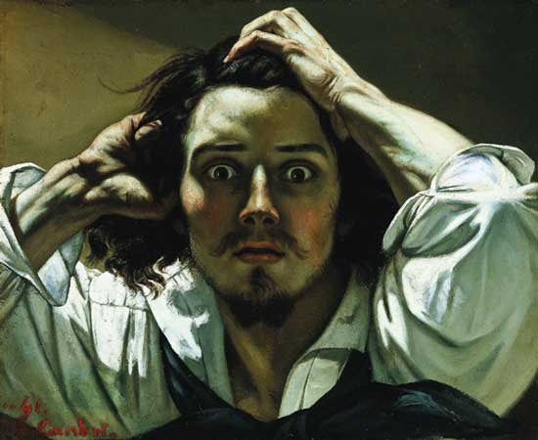
Comprehension Strategy
Before Reading : What is the strategy that you are using to help the child understand the text? These are some examples.
Make a connection | Make inferences | Prediction
Self Monitor | Prior Knowledge | Questioning
Identify Important Information | Visualize | Synthesis

Comprehension Strategy | Language ( What you say to support, teach the comprehension strategy)
Visualize  Make connection | The teacher will begin by showing the scene from Wizard of Oz. After the video is over, the teacher will ask observational questions including “what do you notice between the two worlds”. The teacher will make connections to how the story is written, and that it bounces from reality and imaginary. Connecting how the Wizard of Oz and Dear Mrs. Larue are explained visually is important. The inside book jacket has a great explanation of how the book is written. The teacher goes over the author’s note which will help with the student understanding how the story is written.
During Reading : What is the strategy that you are using to help the child understand the text? These are some examples
Make a connection | Make inferences | Prediction
Self Monitor | Prior Knowledge | Questioning
Identify Important Information | Visualize | Synthesis

Page # | Comprehension or Vocabulary | Language you will use to teach, focus or probe for understanding
17 | Misunderstood | Ike believes that he is misunderstood. What actions did he do that could be thought of in two different ways?
8,  10 | Complain | Ike says he is hurt even though the doctor says he is faking. He is writing to Mrs. larue to complain. He also complains throughout the story in his “imaginary” mindset, saying the school aren’t treating him fairly.
10, 11 | Howl | There are numerous times where Ike he howls or barks. Using the graphic organizer, the teacher can connect howling to wolves howling at the moon.
14 | Appreciate | To be grateful for something. The teacher can guide the student through making a verbal list of things they appreciate.
14 | Desperate | When Ike is on the run, he is desperate for food, water, and shelter. Using water when you’re thirsty as example will help the student understand the meaning.

After Reading
Comprehension Questions
Bloom Taxonomy  Question Type | Question: Have a mix of questions
Knowledge | What is obedience school?  What is a misunderstanding?  Why do dogs go to obedience school?  Why do dogs bark?
Comprehension | Why were the neighbors upset with Ike?  What were some of the reasons Mrs. Larue was upset with Ike?  Why were the cat’s a the top of the fire escape?  How does Ike’s doctor feel about his injury?  Why are the pages in color and in black and white?  Why did Ike think it was okay to eat the chicken pie?  Where did Ike run to after escaping from obedience school?
Application | How is obedience school like elementary school? Compare and contrast.
Analysis | If you were Mrs. Larue, would you believe Ike’s letters? Why or why not?
Synthesis | Write a schedule for the obedience school and what a typical day looks like.
Evaluation | Write a letter to Mrs. Larue from Ike where he decides to be honest about his actions. Using a word bank, the student will also focus on tier two vocabulary words.

Culminating Writing Task

Teacher directions and activities to prepare students for writing:
The student will be writing a letter to Mrs. Larue where Ike is going to be honest about his time at obidence school. They will incorporate vocabulary words from the story using a word bank provided.
Prompt:Now that you have heard Ike’s story, please write a real letter from Ike to Mrs. Larue. This time, Ike needs to be honest with his mistakes! Use the graphic organizer to help with your details. Be sure to use these words when writing your letter, they will help!
Scoring notes or Sample response: Informal assessment: The student needs to use 5 of the vocabulary words from the word bank in complete sentences. The teacher can support the student in their writing.

Differentiation Options (modify by content, process, and/or final product)

English Language Learners (ELL) | The student will be allowed to extra time to complete the assignment.  Using a book on tape and focusing on visual aids to support the student.  The student will make a list of the words they may not know or understand. They can raise their hand for time to write down the word and ask about the definition to put it in their own terms.  The teacher will have the student act out parts of the story, like howling.  The student may bullet their responses but they still must be able to use the vocabulary words in those bulleted sentences.  Utilizing the graphic organizer to help with visualizing key points in the story.
Language learner disabilities | The student will be allowed to extra time to complete the assignment.  The student will make a list of the words they may not know or understand. They can raise their hand for time to write down the word and ask about the definition to put it in their own terms.  The student may bullet their responses but they still must be able to use the vocabulary words in those bulleted sentences.  The teacher will can provide a list of words and pages for the students to use to follow along with.

Any visuals or other supporting documents that you feel support this lesson.

