Victoria

Title and Author: Hotshots by Chris L. Demarest

Grade: 7th

Reading Level: 2.7 | Lexile Level: 600L-700L
Key Understanding: Wildfires are dangerous and require special fire fighters to put out.

Suggested number of days: 4 Common Core ELA Standards:

CCSS.ELA-Literacy.SL.7.2
Analyze the main ideas and supporting details presented in diverse media and formats (e.g., visually, quantitatively, orally) and explain how the ideas clarify a topic, text, or issue under study.

IEP Goals lesson addresses:
By August 2020 T will increase her ability to analyze the main idea of a read aloud as evidenced by her ability to write a three-sentence summary of a story scoring a 3 out of 4 on a retell rubric.

Baselines: If scores are not available to you create a sample score that a student might have.
Student | Vocabulary | Story Grammar/Comprehension | Written Language
SAMPLE CHILD | SS 75 on PPVT | Can name characters  Listening comprehension | SS 70 below grade level
TS | She uses pictures/ symbols to identify unknown words. | She is able to listen to story and ask questions, make accurate predictions and inferences. She is able to identify the character and setting of a story. | She is able to use appropriate punctuation. Can generate ideas that go beyond her capabilities of writing.

Materials:

- Hotshots! Book
- Tier 3 Vocab Cards
- YouTube video https://www.youtube.com/watch?v=9EzcA3KvEsY
- Venn diagram
- Pictures of firemen and hotshots
- Writing worksheet

Before Reading
Cultural Supports, Building Background
- Do a vocabulary match up with pictures involving all fire fighter related vocabulary to have as a reference throughout the story.
- Fill in a Venn diagram for similarities and difference between a firefighter and a hotshot using a picture of each of these to compare
- Discuss wildfires and where they occur then show the YouTube video below
https://www.youtube.com/watch?v=9EzcA3KvEsY

Connecting Activity: (Questions, Conversation about topic):
Have you ever been somewhere that a wildfire could occur?
Do you think a wildfire would happen in this area?
Have you ever been involved in a situation where you had to evacuate? How did that make you feel?

Vocabulary
Word | Contextualize Word  In the story…. | Definition  (kid friendly) | Example beyond story | Bridge to story  Picture
Ignite | “Sparks from a train ignite a field baked for days.” | To cause something to burn | We had to ignite the fire to make our s’mores. | 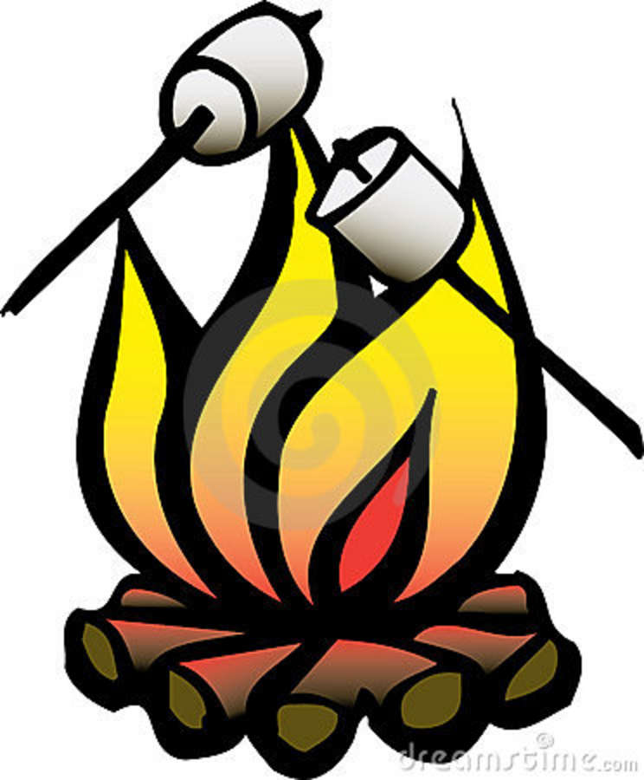
Blaze | “Then winds whip it into a fast-running blaze” | An intense and dangerous fire | The house caught fire and was in a blaze. | 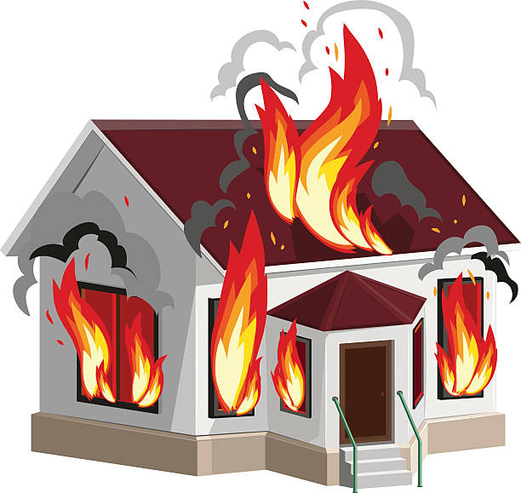
Scene | “On brush rigs and trucks, they head to the scene” | The place of an event or action | The police drove their cars to the scene of the crime. | 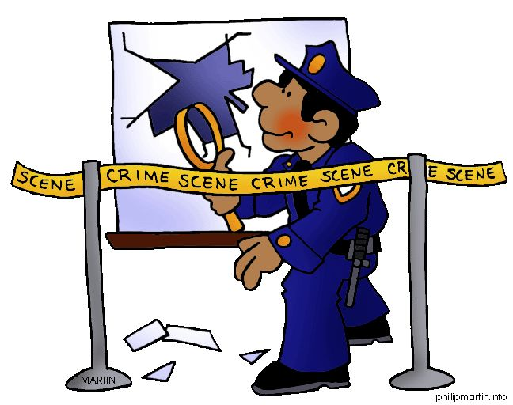
Evacuate | “Police drive through streets, calling “EVACUATE!” | To leave a dangerous place | The students evacuated the school when they heard the fire alarm. | 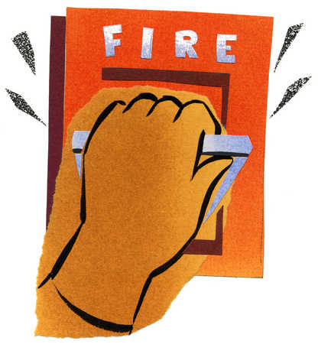
Explodes | “Chaparral explodes and jumps a side street” | To suddenly break with parts flying outwards | If you shake a soda bottle it will explode when you open it. | 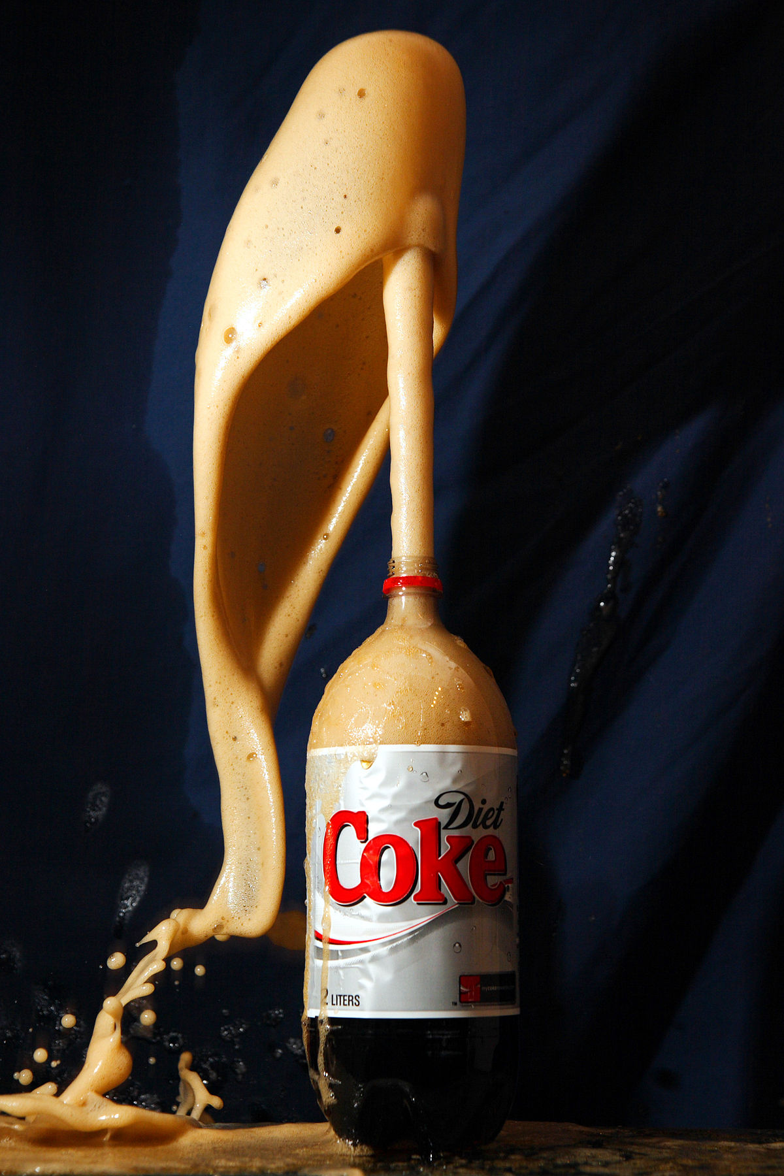
Raging | “While structural crews fight one raging battle, the hotshots race up to the ridge-top saddle” | Very wild and violent | The people stayed away from the raging lion otherwise he would attack them. | 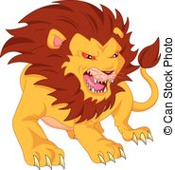
Swoop | “A skycrane swoops down to drop its water load.” | To fly down through the air suddenly | The seagulls at First Beach will swoop down to grab your sandwich if you are not careful. | 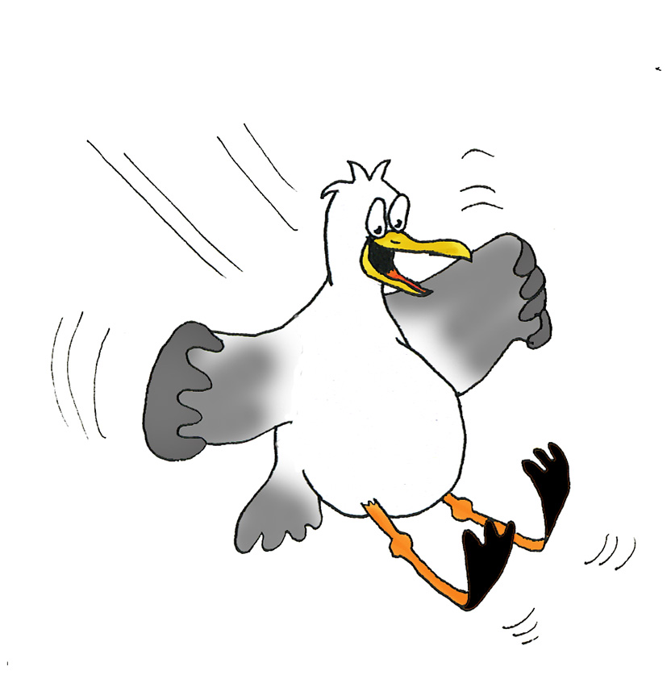

Comprehension Strategy

Before Reading: What is the strategy that you are using to help the child, understand the text? These are some examples.
Make a connection | Make inferences | Prediction
Self Monitor | Prior Knowledge | Questioning
Identify Important Information | Visualize | Synthesis

Comprehension Strategy | Language (What you say to support, teach the comprehension strategy)
Make a connection  Prior Knowledge  Prediction | What does the cover of the book remind you of?  What are the emotions that you are feeling looking at the cover of this book?  What do you know about firemen? Do these look like the firemen you’ve seen before?  What do you think this story will be about? What do you think is happening in this picture?

During Reading: What is the strategy that you are using to help the child understand the text? These are some examples
Make a connection | Make inferences | Prediction
Self Monitor | Prior Knowledge | Questioning
Identify Important Information | Visualize | Synthesis

Page # | Comprehension or Vocabulary | Language you will use to teach, focus or probe for understanding
4 | “Baked”  Make a connection | “What does it mean that the field is baked? Have you ever baked something? What happens when you bake something?” The teacher will get the student to realize when they bake something it is hot, so the grass is “baking” in the sun and is hot when the spark hits it.
4 | “Ignite”  Vocabulary | “What would spark do if it fell on something hot? Let’s look at the picture. What do you think ignite means?” The teacher will use the picture to help the student realize ignite means to set something on fire.
5 | “Blaze”  Vocabulary | “Look at the picture. What do you think blaze means? Notice how the fire is not in one spot now it is also over here” Teacher will get the student to understand blaze means dangerous fire by use of the picture.
7 | Identify important information | “Why were the hotshots called? “
7 | Make a prediction | “What do you think the hotshots are going to do?”
8 | “Scene”  Vocabulary | “What is the scene? Where are they headed?”
8 | Questioning | How do you think the person in the care feels seeing all of those trucks?
10 | Identifying important information | “What is happening to the fire? “
10 | Make a connection | “How would you feel if you saw this in real life?”
12 | “Evacuate”  Vocabulary  Make a connection | “What does it mean to evacuate? Have you ever had to evacuate somewhere? How did that make you feel?” Make connection to having evacuation drills at school for fire alarms.
13 | Identifying important information | “Why is it too late for some of the homes” Point to the pictures of the burning houses.
14 | “Chaparral”  Vocabulary | What is a chaparral? (refer to cards)
14 | “Explodes”  Vocabulary | “Look at this picture and how big the fire is. What do you think explodes means?” If student does not guess correctly “Explodes means to blow-up, or suddenly have parts flying in all directions”
16 | Identifying important information. | “What are the firemen doing here?” Make note that the fireman is putting out the house fires with water
16 | Synthesis | “Why do you think the firemen intervened and didn’t let the fire go out on its own?” (think back to the video)
17 | “Raging”  Vocabulary | “Look at what is happening to the fire now. What does it mean when they say one raging battle?” “What are your feelings looking at this?” “Is the fire large or small if it is raging?”
18 | Questioning | “Where do you think the hotshots are going?”
20 | “Skycrane”  Vocabulary | What is a skycrane? (refer to cards)
20 | “Swoops”  Vocabulary | Show with hands a swopping motion when saying “a skycrane swoops.
20 | Prediction | Do you think the skycrane will put out the fire?
22 | “Drip-torches”  Vocabulary | Refer to picture cards
22 | “Scrub Grass”  Vocabulary | Refer to picture cards
22 | Making connections | “What are the hotshots doing here?” Make a connection to when we learned about “backburn” and how the hotshots create a circle around the fire to contain it.
23 | Identifying important information | “You can see there’s not only a skycrane, but also a plane helping put water on the fire”
24 | “Backburn”  Vocabulary | Refer to picture cards
25 | Questioning | “What is happening to the fire? “
25 | Prediction | “Do you think the fire will ever be put out?”
26 | Identifying important information | “Notice how the hotshots are trying to get rid of some of the scrub grass to prevent it from catching on fire”
29 | Identifying important information | “Why do the hotshots need to get into those tents?” Teacher explain that those will keep them from catching on fire
31 | Visualizing | “How does this picture make you feel? Would you want to be in one of those tents?”
32 | “Debris”  Vocabulary | Refer to picture cards
33 | Connection | How would you feel if you were one of these hotshots? Do you think you could do this job?
36 | Identifying important information | “The fire is out! phew!”
38 | Identifying important information | How do you think all of these people are feeling?
38 | Identifying important information | “So, is that it? Their job is done now?” Teacher makes note of the fact that there will be more fires in the future based on the last sentence ‘for hotshots know there’s more fire to fight’

After Reading

Comprehension Questions

Bloom Taxonomy  Question Type | Question: Have a mix of questions
Knowledge | What is the setting of the story?  Who are the main characters in the story?  How would you describe a hotshot?
Comprehension | What were the town people doing compared to the hotshots?  Explain why everyone had to evacuate.
Application | If you could interview a hotshot what would you ask?  How could you apply what you learned to develop a plan if you were told you had to evacuate from your house?
Analysis | How are hotshots related to firefighters?  What are the different parts of putting out a fire?
Synthesis | What would happen if the hotshots did not put out the fire?  What changes would you make at the beginning of the story to prevent a fire?
Evaluation | Based on what you know, how would you explain the importance of fire safety?  Could this story really happen? Explain why.

Culminating Writing Task

Teacher directions and activities to prepare students for writing:
I want you to think about what this story was about so you can write a three-sentence summary and draw a picture to go along with it. I will give you some time to think about it and you can begin whenever you are ready.

Prompt: Write three sentences describing what happened in the story. Draw a picture to go along with your response.
Scoring notes or Sample response:
Summary: First, a spark from the trains started the fire. The towns people had to evacuate while the hotshots fought the fire. The hotshots put out the fire and were able to relax.

Picture: A picture of hotshots putting out the fire

Differentiation Options (modify by content, process, and/or final product)

English Language Learners (ELL) | All ELL students should be profiled for their readiness on the topic. If they are unsure what a firefighter is build background knowledge on what their job is and explain that hotshots are the same thing but fight fires outside instead of in houses. ELLs will receive picture vocab cards for each of the tier 2 and tier 3 vocabulary words and explicitly teach these terms using their native language words as well. These students should have a copy of the book in front of them in order to make sure of the visuals used in the book. The main goal for these students is to be able to identify what a hotshot is therefore their final writing will be “describe a hotshot” rather than the overall summary of the book. There also should be a translated copy of the book for the child available for them to read before reading the English version.
Language learner disabilities | Students with learning disabilities will have vocabulary cards in front of them as the book is being read. They will have a story chart in front of them for them to identify what happens at the beginning middle and end which the teacher will reference to help them write their three sentences. They will have the chance to hear the book twice. Students can have the book in front of them when being read to. For the writing prompt include sentence starters and allow them to use the book to create their summary.

Any visuals or other supporting documents that you feel support this lesson.
Name: Date:

Directions: Write three sentences to explain what happened in the story Hotshots! When you are done draw a picture to go along with the story.

____________________________________________________________________________________________________________________________________________________________________________________________________________________________________________________________________________________________________________________________________________________________________________________
Picture:

Where
Who
How
Why

Fire Fighters
Hotshots



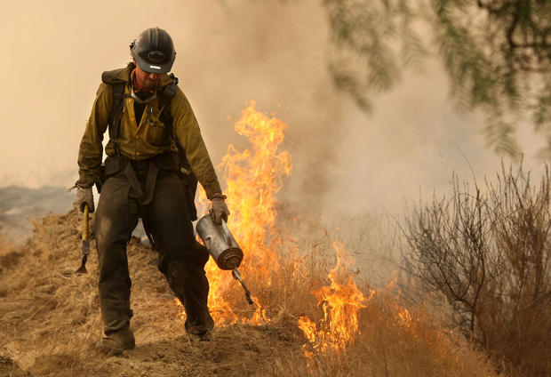
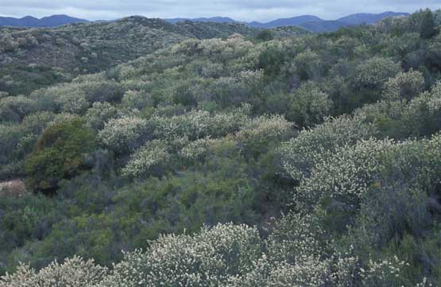
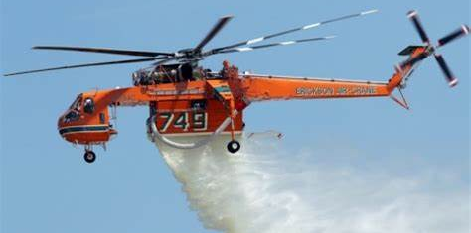
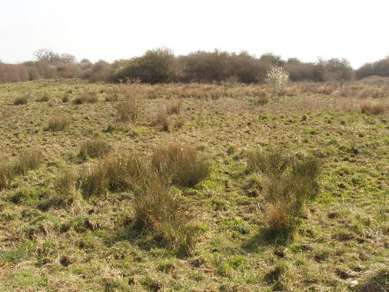
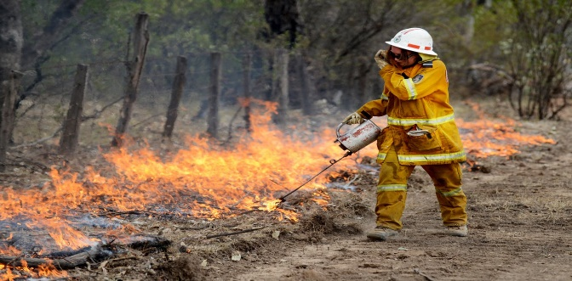
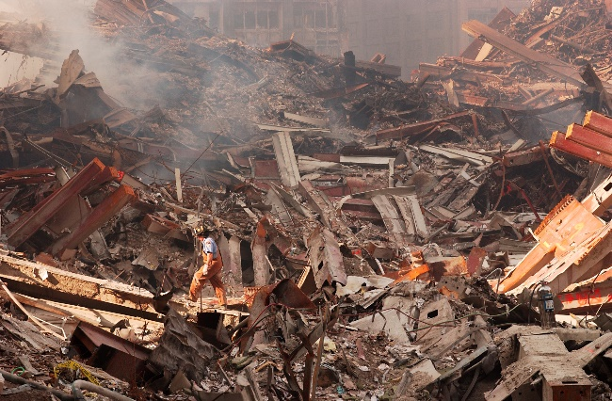
Hotshot
Drip Torch
Chaparral
Skycrane
Scrub Grass
Backburn
Debris
Debris

