Lesson Template

Title and Author: Mr. Lincoln’s Way by Patricia Polacco

Grade: 5

Reading Level: 3.7 | Lexile Level: 620L
Key Understanding: Mr. Lincoln, the principal, knows that “Mean Gene” isn’t really bad – he is just repeating what he hears at home. Can he get through to Eugene and show him that the differences between people are what make them special?

Suggested number of days: 3-5
Common Core ELA Standards: RL.5.1, RL.5.2, W.5.3

IEP Goals lesson addresses:
By August 2018, Zach will increase his reading comprehension of a text by stating the central idea and summarizing key details on an unfamiliar story with 70% accuracy when retelling the story Mr. Lincoln’s Way.

By August 2018, Zach will write expanded simple sentences and beginning complex sentences using structured English word order in a simple paragraph with 60% accuracy when writing a simple personal narrative.

Baselines: If scores are not available to you create a sample score that a student might have.
Student | Vocabulary | Story Grammar/Comprehension | Written Language
Zach | Vocabulary level: 5th grade instructional. | Comprehension and grammar are low. Most thoughts are expressed in phrases. | Oral and written language are low because he does not write or speak in complete and coherent sentences.

Materials:

Mr. Lincoln’s Way by Patricia Polacco

Before Reading
Cultural Supports, Building Background
Looking at front and back cover:
Where does this story take place? (school, maybe on playground)
Who are some of the characters in this story? (school children, adult)
Who do you think the adult in the picture is? (teacher, principal)
Connecting Activity: (Questions, Conversation about topic):
We have previously discussed and read stories about bullying? What does the word bully mean? What does a bully act like?
We have previously read stories and discussed civil rights.
Genre Set-Up, Bridging Conversation, Think-Aloud, Setting Purpose
(What strategy are you highlighting in your lesson)
Before reading the story, the teacher will introduce the characters and the problem in the story. The teacher will begin by saying; “Mr. Lincoln’s Way” is a story about a boy named Eugene. Eugene is a bully and the kids at school call him “Mean Gene”. Mr. Lincoln, the principal, knows that Gene is not really as mean as he seems and Mr. Lincoln thinks that Gene is just saying mean things that he has heard at home. Mr. Lincoln wants to try to get through to Gene because Mr. Lincoln knows that Gene is a good kid. Let’s see what happens.

Vocabulary
Word | Contextualize Word  In the story….. | Definition  ( kid friendly) | Example beyond story | Bridge to story  Picture
wrenched | “… and he pushed her down and wrenched her backpack away.” | pulled away suddenly or violently. | Zach wrenched the video game controller out of Brian’s hands. | 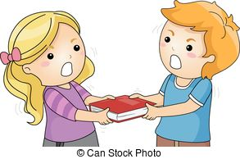
sassed | “Mean Gene sassed the teachers.” | be rude to someone | Jake sassed Ms. S because he didn’t want to read Lemonade War. | 
glum | “…when Eugen ran into Mr. Lincoln looking glum.” | sad or depressed | Rob looked glum when his team lost the soccer game. | 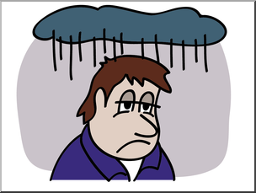
commotion | “It was only three days later that there was a commotion in the hall.” | noisy excitement and confusion | There was a commotion in the classroom when Sarah saw that it was snowing outside! | 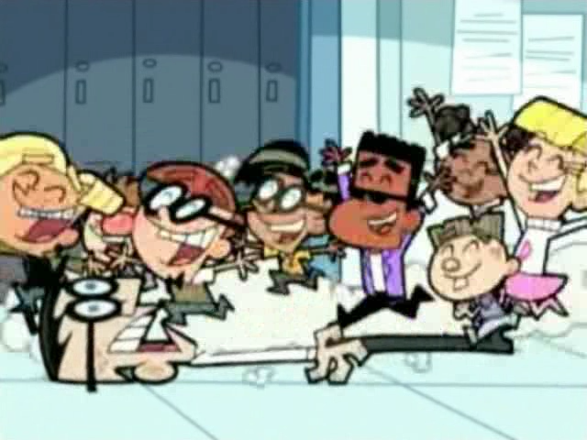
defiant | “He sat looking hateful and defiant” | refusing to obey someone or something | Jackie was defiant when she ran in the hallways. | 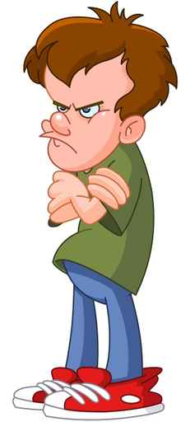
atrium | “…Mr. Lincoln was helping the fifth grade plant a tree in the beautiful new atrium,…” | an open area inside a building that has windows to let light in from above | Mrs. Mazzella left her beautiful plants in the atrium at ELMS so they would get enough sunlight. | 
coax/  coaxing/coaxed | “Now they talked to the ducklings, coaxing them to follow.” | to persuade someone to do something in a friendly way | It took over an hour to coax the cat down from the tree. | 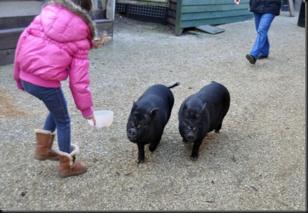

Comprehension Strategy

Before Reading : What is the strategy that you are using to help the child understand the text? These are some examples.
Make a connection | Make inferences | Prediction
Self Monitor | Prior Knowledge | Questioning
Identify Important Information | Visualize | Synthesis

Comprehension Strategy | Language ( What you say to support, teach the comprehension strategy)
Prediction/Questioning/ Make inferences  Make a connection  Visualizing  Prior Knowledge | - The teacher will have the students look at the front and back covers of the story.  - Tell me what you see.  - Why do you think the story is called Mr. Lincoln’s Way?  - What do you think the story is about?  - Where do you think the story takes place?  - Who do you think the characters are in this story?  - Who do you think Mr. Lincoln is?  - After reviewing the cover, the teacher will introduce the text and explain to the students, “Today we are going to read a book called Mr. Lincoln’s Way. It is about a boy named Eugene or Gene who is a bully. The other kids at school call him “Mean Gene”. Have you ever seen a bully? What do bullies act like?Mr. Lincoln, the principal, knows that Gene is not really as mean as he seems and Mr. Lincoln thinks that Gene is just saying mean things that he has heard at home. Mr. Lincoln wants to try to get through to Gene because Mr. Lincoln knows that Gene is a good kid. Let’s see what happens.”  - The teacher will read aloud the entire story, Mr. Lincoln’s Way.  - During the reading, the teacher will explicitly teach the vocabulary words; wrenched, sassed, glum, commotion, defiant, atrium, and coax.  - The teacher will review the Tier I words while reading

During Reading : What is the strategy that you are using to help the child understand the text? These are some examples
Make a connection | Make inferences | Prediction
Self Monitor | Prior Knowledge | Questioning
Identify Important Information | Visualize | Synthesis

Page # | Comprehension or Vocabulary | Language you will use to teach, focus or probe for understanding
1-2 | Identify Important Information | Who is Mr. Lincoln? Why do the students think he is cool?
3-4 | Identify Important Information  Make a connection  Questioning | Who is Eugene? What do the kids at school call him? Mean Gene sassed the teachers. Have you ever seen a classmate sass the teachers? Why did they sass the teachers? Why is Eugene considered a bully? Does Mr. Lincoln think Eugene is a bad boy? What are some words you would use to describe Gene?
5-6 | Visualize  Make a connection  Questioning | The teacher will have the students look at the picture on pages 5 and 6. What is happening in the picture? Eugene wrenched the backpack out of the first-grader’s hand. What do you think the other students are saying to Mr. Lincoln? Have you ever seen something like this happen on the playground? What did you do?
7-8 | Make inferences  Prediction  Questioning | Why do you think Eugene was staring at the birds so often? Mr. Lincoln was helping the fifth grade plant a tree in the beautiful new atrium. What do you think Mr. Lincoln was thinking?
9-10 | Identify Important Information  Make inferences | What is Gene interested in? How does Gene know about different types of birds? Does Gene like Mr. Lincoln?
11-12 | Identify Important Information  Make inferences  Make a connection | Why was Mr. Lincoln looking glum? Why do you think he asked for Gene’s help? How do you think Gene felt when Mr. Lincoln asked him for help? Has a teacher ever asked for your help? Why did they ask?
13-14 | Visualize  Synthesis  Make inferences | How do you think Gene is feeling now? How do you know? What changes are Gene’s teachers noticing? How do you think Gene feels about Mr. Lincoln now? Why do you think Gene changed?
15-16 | Make inferences  Questioning | How do you think Gene feels knowing that he helped bring birds back to the atrium? How did Gene’s behavior change? How do you think the other children feel about Gene now?
17-18 | Synthesis | Why isn’t Gene mean anymore? What made him change?
19-20 | Identify Important Information  Make a connection  Questioning | Who caused the commotion in the lunch line? Why did Gene pick on other the other students? Have you seen someone be picked on for how they look? How do you think Mr. Lincoln feels? Why do you think Eugene just sat looking hateful and defiant? Where did Gene learn his mean behavior?
21-22 | Synthesis | How did Mr. Lincoln get Gene to see that all kinds of people are beautiful and that our differences make us special? Why did Mr. Lincoln use the birds as an example?
23-24 | Synthesis | Where has Gene learned his bad behavior? Who does Gene look up to?
25-26 | Questioning  Prediction | How do you think Gene feels seeing the ducklings hatching? What do you think is going to happen next?
27-28 | Prediction | How do you think Mr. Lincoln and Eugene are going to get the ducklings out of the atrium and to the pond?
29-30 | Identify Important Information  Synthesis  Questioning | Why do you think the other students were asked to stay in their rooms? Why do you think Mr. Lincoln trusted Eugene to help him in the atrium? How did Mr. Lincoln and Eugene coax the ducklings out of the atrium? What are some other ways they could have coaxed the ducklings towards to pond?
31-32 | Synthesis | How do you think Gene feels as the ducks are leaving the atrium?
35-36 | Identify Important Information  Questioning | Who came to see the ducklings? Why do you think Gene wants to stay with his Grandpa? Who helped get Eugene’s Grandpa to school?
37-38 | Questioning  Identify Important Information  Prediction | How did Eugene help Mr. Lincoln? How did Mr. Lincoln help Eugene? How doe Eugene feel about Mr. Lincoln? How has it changed since the beginning of the story? What does Eugene promise Mr. Lincoln? How did Gene’s behavior change from the beginning of the story? How do you think Gene will behave from here on out? What are some words you would use to describe Gene now?

After Reading

Comprehension Questions

Bloom Taxonomy  Question Type | Question: Have a mix of questions
Knowledge | Who is Mr. Lincoln?  Who is Eugene?  What is the problem in the story?  Where does the story take place?
Comprehension | What is the main idea of the story?  How are Mr. Lincoln and Gene the same? How are they different?
Application | Why do you think Eugene acted the way he did?  What is the theme of the story?
Analysis | Suppose a bully like Gene went to your school. What would you do to try to change the bully’s behavior?
Synthesis | What is another way that you could coax the ducklings out of the atrium?
Evaluation | How is Gene different at the end of the story?  What did Mr. Lincoln learn from Gene?  What did Gene learn from Mr. Lincoln?

Culminating Writing Task

Teacher directions and activities to prepare students for writing:

Prompt: How did Gene change throughout the story? Tell about some of Gene’s characteristics at the beginning of the story and at the end of the story. Discuss some of the events that contributed to this change.
Scoring notes or Sample response:
See rubric below
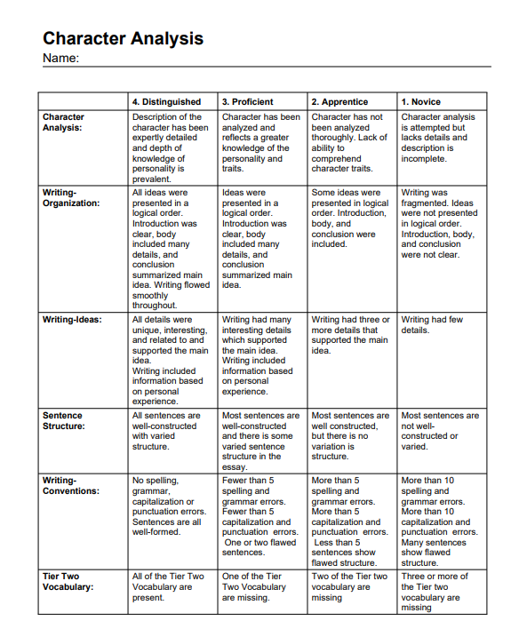
Differentiation Options (modify by content, process, and/or final product)

English Language Learners (ELL) | The student will be allowed extra time to complete the assignment.  The student may bullet their responses.  The student will be given the page numbers ahead of time as to where the tier two/tier three vocabulary are located as a reference, to when they are writing the prompt.  The teacher will ask the student to make a list of the words that they do not comprehend, as they read the text, and we will go over these words.  The teacher will ask the student to look at the cover to the story, and tell the teacher what they know about the images.  Use of a graphic organizer to organize thoughts and ideas for writing prompt.
Language learner disabilities | The student will be given the page numbers ahead of time as to where the tier two/tier three vocabulary are located as a reference, to when they are writing the prompt.  The teacher will ask the student to make a list of the words that they do not comprehend, as they read the text, and we will go over these words.  The student will be allowed to extra time to complete the assignment.  The student may bullet their responses.  Use of graphic organizer to organize thoughts and ideas for writing prompt.

Any visuals or other supporting documents that you feel support this lesson.
Graphic organizer:
