Tania DiMartino EDU 571 July 31, 2018

Title and Author:

The Three Ninja Pigs by Corey Rosen Schwartz
Grade: 3rd grade
Reading Level: 2nd grade | Lexile Level AD630L
Key Understanding: Reinforces the purpose for developing perseverance to overcome a difficult situation and understanding that practice makes perfect.

- The student will know how to summarize the key events in the story.
- The student will identify the story elements in the story to reinforce the moral lesson of perseverance.
- The student will learn the strategy for using context clues to comprehend new vocabulary.
Suggested number of days: 2-3 days

Common Core ELA Standards:

Key Ideas and Details:
CCSS.ELA-LITERACY.RL.3.1
Ask and answer questions to demonstrate understanding of a text, referring explicitly to the text as the basis for the answers.

CCSS.ELA-LITERACY.RL.3.3
Describe characters in a story (e.g., their traits, motivations, or feelings) and explain how their actions contribute to the sequence of events

Craft and Structure:
CCSS.ELA-LITERACY.RL.3.4
Determine the meaning of words and phrases as they are used in a text, distinguishing literal from nonliteral language.

Vocabulary Acquisition and Use:

CCSS.ELA-LITERACY.L.3.4.A

Use sentence-level context as a clue to the meaning of a word or phrase.

Comprehension and Collaboration:

CCSS.ELA-LITERACY.SL.3.2

Determine the main ideas and supporting details of a text read aloud or information presented in diverse media and formats, including visually, quantitatively, and orally.
IEP Goals lesson addresses

By March 2018, given an instructional level text, Adeline is expected to summarize the
main ideas and supporting details in a text to sustain meaning and logical order with 70%
accuracy in 3 out of 5 assignments as measured by informal student work samples and/or observations.

By March 2018, given an instructional level text, Adeline is expected to use the context of
the sentence in the text to determine the meaning of unfamiliar words or
multiple meaning words with 70% accuracy in 3 out of 5 opportunities as measured by informal student work
samples and/or teacher observations.

Baselines: If scores are not available to you create a sample score that a student might have.
Student | Vocabulary | Story Grammar/Comprehension | Written Language
SAMPLE CHILD | SS 75 on PPVT | Can name characters  Listening comprehension | SS 70 below grade level
Adeline M. | MAVA: Montgomery Assessment of Vocabulary Acquisition  Tier One Vocabulary 95%  Tier Two Vocabulary 35%

Materials:

The Three Ninja Pigs by Corey Rosen Schwartz book
https://kids.kiddle.co/Karate history video about Japanese karate
Design a Ninja Pig template
Popping New Word template

Before Reading
Cultural Supports, Building Background

The teacher will discuss the history of Japanese karate, colored belts, and clothing via the kid friendly website called https://kids.kiddle.co/Karate with the student. The teacher will use visuals to help the student understand the meaning for selected Japanese terms printed in the book (ex. ninja, aikido, jujitsu, san, sayonara, sensi, and karate).
Connecting Activity: (Questions, Conversation about topic):

Do you know the story of The Three Little Pigs?
What is a ninja?
What clues from the illustrations can you give about where this
story might take place?
What can you predict about the pigs in the story based on the
book's title?

(The student will design their own ninja pig using the provided template from the teacher.)

Genre Set-Up, Bridging Conversation, Think-Aloud, Setting Purpose
(What strategy are you highlighting in your lesson)

The teacher will help the student identify the story elements and summarize the main events in The Three Ninja Pigs to emphasize that persevering through challenging circumstances can build character.

Vocabulary
Word | Contextualize Word  In the story….. | Definition  (kid friendly) | Example beyond story | Bridge to story  Picture
outrivaled | “The wolf saw that he was outrivaled.”  The wolf in the story suddenly realizes that Pig 3 isn’t going to be quite easy to defeat on his own like Pig 1 and Pig 2. | When you notice the person, you have to compete against will be better then you. | During the singing competition, she had to face a series of challenges in order to outrival her contestants. | 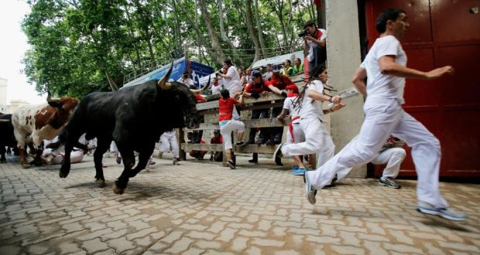
persisted | “For months, she’d persisted in earnest until she had paid all her dues.”  Pig 3 carried on with determination to master all the karate skills necessary to earn all the colored belts including the very last one. | To continue on without giving up. | If your son's fever persists more than two days, you'd better take him to the doctor again. | 
hollered | “The wolf chased Pig one to his brother’s home and hollered Hey, pigs, let me in!”  The wolf yelled angrily because Pig 1 made a fist and swung at him. | To call out loudly | He was hollering outside the window to the children playing across the street. | 
earnest | “For months, she’d persisted in earnest until she had paid all her dues.”  Pig 3 was serious about earning all the belts because she wanted to defeat the wolf. | To be completely serious | Despite her earnest efforts, she could not find a job. | 
heaped | “Pig three heaped some bricks in a pile.”  Pig 3 piled up the bricks to show the wolf that she was strong enough to smash through the bricks. | To gather up and put into a pile | There was a heap of papers stacked on the teacher’s desk. | 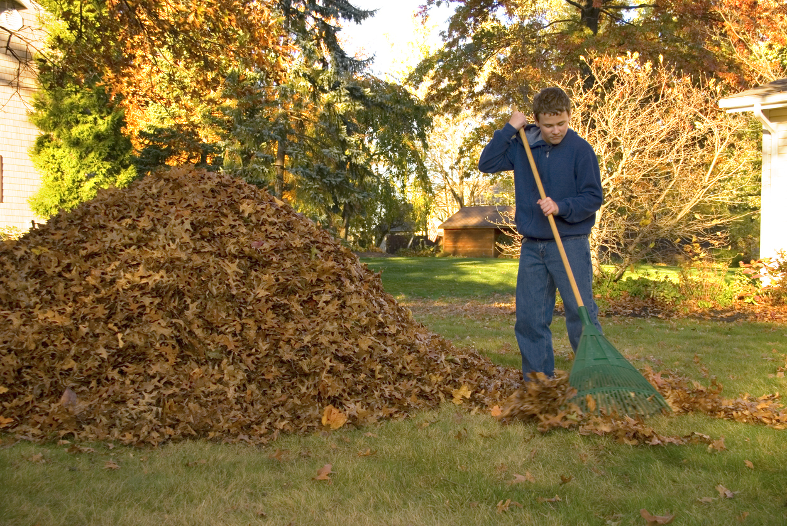

Comprehension Strategy

Before Reading: What is the strategy that you are using to help the child understand the text? These are some examples.
Make a connection | Make inferences | Prediction
Self Monitor | Prior Knowledge | Questioning
Identify Important Information | Visualize | Synthesis

Comprehension Strategy | Language (What you say to support, teach the comprehension strategy)
Prediction  Questioning | Before reading The Three Ninja Pigs, the student will look at the cover.  - What do you think the book will be about? Why do you think so?  - Where does this story take place? Can you find clues in the illustrations? Do you think this takes place where you live? Or someplace far away?

During Reading: What is the strategy that you are using to help the child understand the text? These are some examples
Make a connection | Make inferences | Prediction
Self Monitor | Prior Knowledge | Questioning
Identify Important Information | Visualize | Synthesis

Page # | Comprehension or Vocabulary | Language you will use to teach, focus or probe for understanding
6-7 | “Let’s train at that new Ninja school!”- Why do the pigs decide to train at the Ninja school?  What problem are they trying to solve? | student response: The pigs want to train at the ninja to stop the wolf from bullying them.
8 | What does the word aikido mean on page 8? | Aikido: a method of self-defense that utilizes wrist, joint, and elbow grips to immobilize or throw one’s opponent.

After Reading

Comprehension Questions

Bloom Taxonomy  Question Type | Question: Have a mix of questions
Knowledge | Why did Pig One drop out of ninja school?  Why did Pig Three decide to show the wolf her karate moves?
Comprehension | Why did the pigs train at the ninja school?  Why was Pig Three so good at Karate?
Application | How does the author keep the story similar to original version of The  Three Little Pigs?
Analysis | Describe the training Pig three did. Did she work hard? Explain.
Synthesis | Do people who practice karate really learn to break bricks? How could  you tell if the author accurately represented martial arts? What further  questions do you want to know about Japanese karate? Where could you go to discover more information about martial arts?
Evaluation | Pig One said he “I wish I’d been way more prepared!”. Why is it so important to be  prepared before attempting a new challenge? What do you think Pig One would need to do so he’s prepared when the wolf decides to visit again?

Culminating Writing Task

Teacher directions and activities to prepare students for writing

Prompt:
1) Have you ever stopped working on something because you thought you had already mastered it, but found out later you needed more practice? Make a personal connection to Pig Two.

2) What is one goal you want to get accomplish in school or later in life? How will you accomplish that goal? What steps will you need to do for accomplishing that goal?

Scoring notes or Sample response:

Differentiation Options (modify by content, process, and/or final product)

English Language Learners (ELL)
Language learner disabilities

Any visuals or other supporting documents that you feel support this lesson.

