Lesson Plan: Empty Pot by Demi

Title and Author:
The Empty Pot by Demi
Grade:
2nd Grade
Reading Level: M | Lexile Level: 630 L
Key Understanding: The main idea of this book and lesson is to teach the importance of honesty. Being honest with yourself and being honest with others.

Suggested number of days: 3

Common Core ELA Standards:
- RL.6.2 Determine a theme or central idea of a text and how it is conveyed through particular details; provide a summary of the text distinct from personal opinions or judgements.

- RL.6.3 Describe how a particular story’s or drama’s plot unfolds in a series of episodes as well as how the characters respond or change as the plot moves towards a resolution.

IEP Goals lesson addresses
- Student will be able to accurately identify the central idea or theme of a text, with only one prompt from teacher and with 85% accuracy, by January 2018.

- Student will be able to accurately retell a text including characters, setting, and plot with 90% accuracy, by March 2018.

Baselines: If scores are not available to you create a sample score that a student might have.
Student | Vocabulary | Story Grammar/Comprehension | Written Language
Jake Smith | SS 70 on PPVT | Can name characters  Listening comprehension  Retell a story | SS 65 below grade level

Materials:

- The Empty Pot by DEMI
- China Culture Video- https://www.youtube.com/watch?v=UIpm2PWBzow&t=208s
- Story Props- crown, flower, empty pot
- Vocabulary cards with pitctures
- The Empty Pot on Video-(ELL and Language Learner Student)- https://www.youtube.com/watch?v=fvRbPr6MqjI
- Writing Prompt, Brainstorming Sheet, Teacher Writing Rubric, and Student Writing Rubric
- KWL Chart

Before Reading
Cultural Supports, Building Background
To build background and have cultural support a video of Chinese culture will be shown. This video is about 9 minutes and will highlight important ideas of Chinese culture, history, important places in China, animals, and other ideas that will help explain the Chinese culture, specifically designed for children.

Connecting Activity: (Questions, Conversation about topic):
To connect the video to the reading and have a conversation about Chinese culture, a pre discussion in the form of a KWL chart will be done. What does the student already know about China and Chinese culture, and what are they wondering about Chinese culture. Teacher will prompt student if stuck with various questions such as, do you think the food is the same? Do you think they have similar celebrations? What are you wondering about how they live, their houses, what their schools look like?

Genre Set-Up, Bridging Conversation, Think-Aloud, Setting Purpose
(What strategy are you highlighting in your lesson)

The strategy that is being highlighted in this lesson is genre set-up. The focus will be on the theme of the story, honesty, along with how the characters feel and how they change throughout the story. This will allow for students to be in the position of the characters and try to understand how they feel at certain points throughout the story and connect with these characters. A conversation about how they may be feeling, a time they felt like that, or a time they may have made someone feel a certain way will be had.

We will also go through vocabulary words that will be in the story. The student will see the picture and read the definition. Student will fold the definition behind the picture. This way if they are stuck on the word they will have the picture clue to help them.

Vocabulary
Word | Contextualize Word  In the story….. | Definition  ( kid friendly) | Example beyond story | Bridge to story  Picture
Emperor | The emperor of China was an old man who did not have any children. | One who rules the land. | The emperor told all of his people to work really hard. | 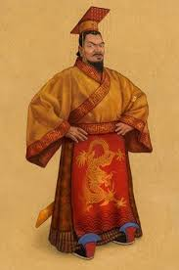
glum | Ping looked at his own empty pot and felt glum.6 | Someone who is moody or sulking. | They looked glum but later they cheered up. | 
Encouraged | “You did your best,” she encouraged. | Giving someone support, confidence, or hope. | The teacher gave the student encouragement when they thought they couldn’t complete the math work. | 
Sprout | The seed did not sprout. | To grow. | A new plant will sprout from the ground in the spring | 
Weeping | His mother saw Ping weeping. | Shedding tears, crying. | The boy was weeping because he missed his mother. | 

Comprehension Strategy

Before Reading : What is the strategy that you are using to help the child understand the text? These are some examples.
Make a connection | Make inferences | Prediction
Self Monitor | Prior Knowledge | Questioning
Identify Important Information | Visualize | Synthesis

Comprehension Strategy | Language ( What you say to support, teach the comprehension strategy)
Make a connection/Prior Knowledge | The main idea of this text is to understand the importance of honesty. In order to do this a conversation, making a connection, will be done. We will discuss different situations when the student was/wasn’t honest. How did they feel? Why were they honest? Why were they not honest? How did the other people involved in the situation feel? What could they have done instead?  Also, for better understanding, connecting to prior knowledge b using the KWL Chart and the video on Chinese culture will help the student understand the setting of the text with better understanding.

During Reading : What is the strategy that you are using to help the child understand the text? These are some examples
Make a connection | Make inferences | Prediction
Self Monitor | Prior Knowledge | Questioning
Identify Important Information | Visualize | Systenhesis

Page # | Comprehension or Vocabulary | Language you will use to teach, focus or probe for understanding
6 | Comprehension: How is Ping feeling when his plant is not growing? | Have you ever done something and it did not turn out the way that you planned?  How did you feel?  What made you feel that way?
8 | Vocabulary: well | What do you think a well is?  Look at the picture to help you and use context clues.  How you ever watched a movie or a read a book where a character needs to go to a well?
10 | Comprehension: Why did his mother encourage Ping? | Has your mother ever tried to help you?  When you are feeling glum, who helps you feel better?  How do you feel when someone tries to make you feel better?
14 | Vocabulary: Honest | What does it mean to be honest?  How do you feel when you are honest?  Have you ever been dishonest?

After Reading

After the story has been read before comprehension question the student will re-tell the story. Then teacher will use given props, crown, flower, and empty pot. The teacher will give the student the crown and ask how they feel to be emperor, at the beginning, middle and end of the story. Then the teacher will give the student the empty pot and ask them to pretend they are Ping. How did Ping feel at the beginning middle and end of the story? Then the teacher will give the student the pot with a flower in it and ask to pretend that they are the other children of the village. How did they feel at the beginning middle and end of the story? Then the teacher will give the student the crown and tell them that they are the successor to the emperor. How do you feel? Why were you choose to be the successor?
Then student will go back into the KWL chart and fill out at least three things that they learned about China in the L column.

Comprehension Questions

Bloom Taxonomy  Question Type | Question: Have a mix of questions
Knowledge | Who are the main characters in the story?  When and where did the setting of the story take place?  What is the problem in the story?
Comprehension | Re-tell the story The Empty Pot in your own words.  What is the main idea of The Empty Pot?
Application | Can you think of an instance in your life where being honest is important?  What do you think is another way that the Emperor could have determined a successor?
Analysis | How does Ping compare to the other children in the story?  How is Ping different from the other children in the story?
Synthesis | What do you predict would happen if Ping was not honest?  How can you infer that the other children of the village where feeling after not being honest?
Evaluation | Do you agree that Ping should have been rewarded for being honest?  What is the most important lesson from this story?

Culminating Writing Task

After lesson is completed teacher will prompt student with given writing prompt. Together teacher and student will develop a brainstorming idea, using given writing tool, to help organize ideas. Teacher will make sure that student’s ideas are on task and will assist in organization. After brainstorming is completed, teacher will let student begin writing assignment. After writing assignment is completed teacher will use given rubric to assess student. Teacher will review writing assignment and rubric will student to go over skills that were successful and skills that need to be improved.

Prompt: Pretend that you are child, other than Ping, from the story. What would you give the Emperor and why?
Scoring notes or Sample response:

Use Attached Rubric.
Use Attached Writing Sample.

Differentiation Options (modify by content, process, and/or final product)

English Language Learners (ELL) | - Deliver content or lesson in chunks  - Provide extra time for completion  - Show a video clip of China in student’s native language  - Define any figurative language  - Use audio or video supports in native language  - Provide multiple learning opportunities to reinforce key concepts and vocabulary.  - Provide cross-content application or concepts to help tie learning together to make it more comprehendible.  - Incorporate technology with online programs to allow opportunities to practice in various ways, ability to work at own pace, and find effective data about strengths and weakness for teacher support.
Language learner disabilities | - Repeat back what the student has said, modelling the correct pronunciation, word form or sentence structure.  - Allow students to answer verbally instead of written responses.  - Provide the student with choices of correct grammar, sentence structure or word choice to help them process the correct form or word to use. For example: “Is it a giraffe or an elephant?”, “If it’s a boy, is it he or she?”  - Be patient when the student is speaking; not rushing a student  - Use visuals to support expressive language skills. Pictures or written cues can be used to prompt the student to use a longer utterance or initiate a phrase within a specific situation or activity.  - Help build the student’s vocabulary by creating opportunities for focusing on language processing skills, such as sorting and grouping, similarities and differences.  - Help students connect new words and information to pre-existing knowledge.  - Use pre-planning strategies for oral and written tasks.  - Pair the student up with another student to increase partner communication.  - Prepare students for verbal question-answering (inform them of when they will be called upon; allow preparation time for a response; provide extra time when they are responding)

Any visuals or other supporting documents that you feel support this lesson.

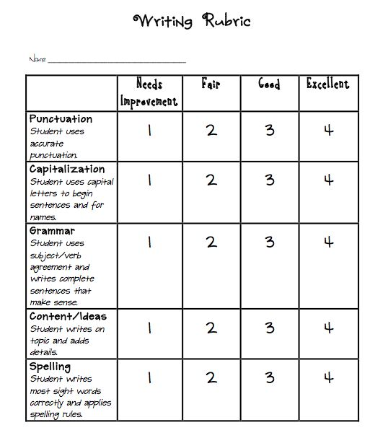

Pretend that you are child, other than Ping, from the story. What would you give the Emperor and why?

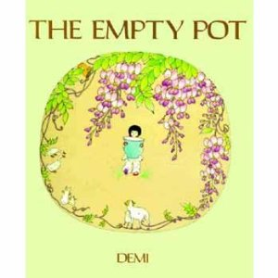
________________________________________________________________________________________________________________________________________________________________________________________________________________________________________________________________________________________________________________________________________________________________________________________________________________________________________________________________________________________________________________________________________________________________________________________________________________________________________________________________________________________________________________________________________________________________________________________________________________________________________________________________________________________________________________________________________________________________________________________________________________________________________________________________________________________________________________________________________________________________________________________________________________________________________________________________________________________________________________________________________________________________________________________________________________________________________________________________________________________________________________________________________________________________

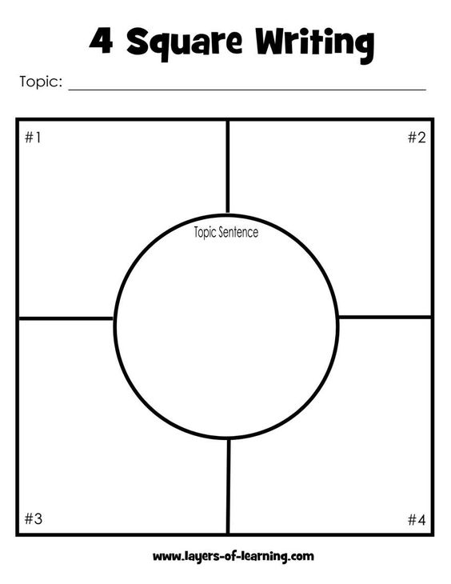

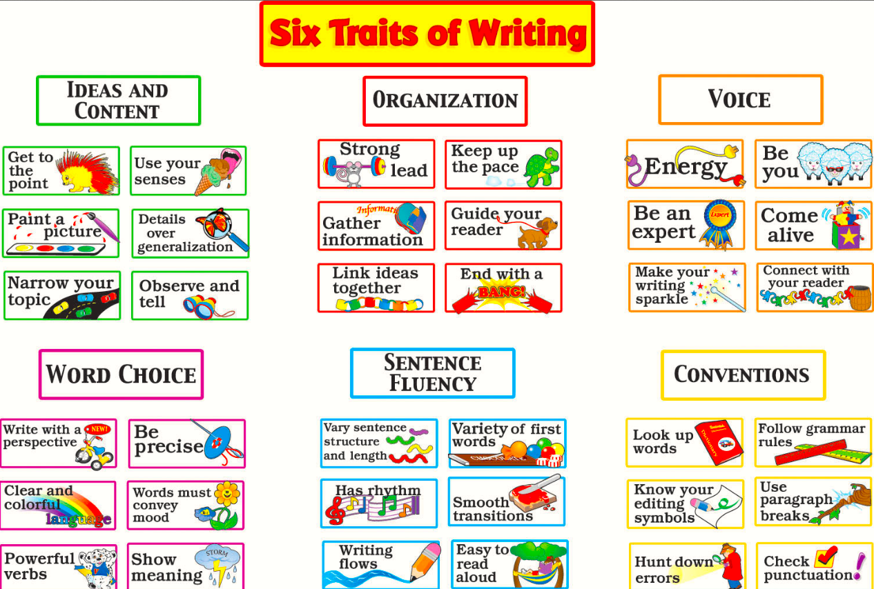

Emporer:One who Glum:moody of sulking
rules the land.

Encouragement: giving Sprout: To grow
someone support
confidence or hope.

Weeping: crying, shedding tears

What do I know, am wondering, and have learned about China?

K W L

