Lesson Template

Title and Author: “The Monkey’s Paw” by W.W Jacobs (Adapted Version)

Grade: High School (9-12)

Reading Level: 8 | Lexile Level 700L
Key Understanding: Be Careful what you wish for
Students will understand literary elements plot. In that a plot is the sequence of related events in a story that revolves around a conflict, or a struggle between opposing forces and follows a structure or pattern: exposition, rising action, climax, falling action, and resolution).
Students will develop the reading skill of making predictions. A prediction is a logical idea about what will happen. To make predictions, students will pay attention to story details and use their prior knowledge of prior stories and human nature to predict events and how characters in a story will act.

Suggested number of days: ___3___Common Core ELA Standards:
CCSS.ELA-LITERACY.RL.9-10.2
Determine a theme or central idea of a text and analyze in detail its development over the course of the text, including how it emerges and is shaped and refined by specific details; provide an objective summary of the text.
CCSS.ELA-LITERACY.RL.9-10.5
Analyze how an author's choices concerning how to structure a text, order events within it (e.g., parallel plots), and manipulate time (e.g., pacing, flashbacks) create such effects as mystery, tension, or surprise.
CCSS.ELA-LITERACY.W.9-10.3
Write narratives to develop real or imagined experiences or events using effective technique, well-chosen details, and well-structured event sequences.
CCSS.ELA-LITERACY.W.9-10.3.C
Use a variety of techniques to sequence events so that they build on one another to create a coherent whole.
CCSS.ELA-LITERACY.L.9-10.2
Demonstrate command of the conventions of standard English capitalization, punctuation, and spelling when writing.
CCSS.ELA-LITERACY.L.9-10.5
Demonstrate understanding of figurative language, word relationships, and nuances in word meaning

IEP Goals lesson addresses ( Taken from student’s IEP)
When reading grade level texts with teacher, Jaime will complete accurate, objective summaries of the readings. He will score at least a 70% on comprehension of the material read.
When writing, Jaime will produce clear and coherent writing in which the development, organization, and style are appropriate to task, purpose, and audience in order to improve his written work to a 4, or capable, on the 6+1 Writing Rubric.

Baselines: If scores are not available to you create a sample score that a student might have.
Student | Vocabulary | Story Grammar/Comprehension | Written Language
Jaime | On the Brigance Vocabulary Comprehension Assessment, Jaime scored at a 3rd grade level | According to the Brigance Reading Assessment, when reading for comprehension and independent reading, Jaime can read at a 4th grade level independently and score 50% on comprehension. | According to the 6+1 Writing Rubric, Jaime produces written works equivalent to a 2, which is known as Emerging. He usually has a main idea that begins to emerge but lacks direction at times. He needs prompts to vary his sentence. He can use simple sentences to best describe his thoughts and ideas.

Materials:

Copy of the story “The Monkey’s Paw,” by W.W. Jacobs (Adapted Version, Prentice Hall: Readers Notebook)
Page 31 from Literature Text Book Prentice Hall
Copy of tier-2 vocabulary words
Copy of the Note-taking Guide/Graphic Organizer Chart
Copy of the Support for Writing and Extended Learning: Writing a sequel questions
Copy of “Meet W.W. Jacobs: “short bio and Background for the Story” p 31 in the textbook.
Hear It! Audio CD (Prentice Hall)
Computer with Word Processing Program, Internet, and Panaboard with projector
Pen or Pencil

Before Reading
Cultural Supports, Building Background
Teacher will read a brief passage about the author W.W. Jacobs and then read the background for the story: The British View of India. India was a British colony form the late 1700’s till 1947. “The Monkey’s Paw tells a story about a strange object that arrives in England from India. Many soldiers who would come back to England would bring back mysterious tales about India’s culture, some of it untrue. Before long, India came to represent the mysterious and supernatural.

Connecting Activity: (Questions, Conversation about topic):
To activate prior knowledge, ask students if they ever heard the expression; “Be careful what you wish for?” Have students share what they think the sentence means. Then ask why someone should be careful about wishing. Provide an example if students are having difficulty.

Genre Set-Up, Bridging Conversation, Think-Aloud, Setting Purpose
(What strategy are you highlighting in your lesson)
Pass out a copy of the Literary Analysis and Reading Skill handout. The literary Analysis part explains plot and the patterns that most stories follow. Ask students to share a favorite popular movie and use the example to discuss and demonstrate each element of plot. If the teacher isn’t familiar with the movie use a movie that is popular, such as “Star Wars.”
The reading skill will involve making predictions. Ask students when watching a movie or reading a story if they are able to predict what may happen next and have them give an example.

Vocabulary
Word | Contextualize Word  In the story….. | Definition  ( kid friendly) | Example beyond story | Bridge to story  Picture
dubiously | Mr. White took the paw from his pocket and eyed it dubiously. | (adv). doubtfully | The detective looked dubiously at the suspect after listening to his story. | 
jarred | His manner was so impressive that his hearers were conscious that their light laughter jarred somewhat. | (v.) shocked because of an unpleasant noise | The little girl’s scream after seeing a spider jarred the little boy. | 
presumptuous | The soldier regarded him in the way that middle age is wont to regard presumptuous youth. | (adj.) overly confident | I hope I won’t be considered presumptuous if I try to offer advice. | 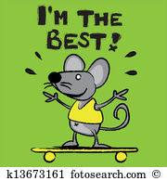
inaudible | There was no reply; the old woman’s face was white, her eyes staring, and her breath inaudible; | (adj.) too quiet to be heard | The dog could hear the whistle, but to a person it is inaudible. | 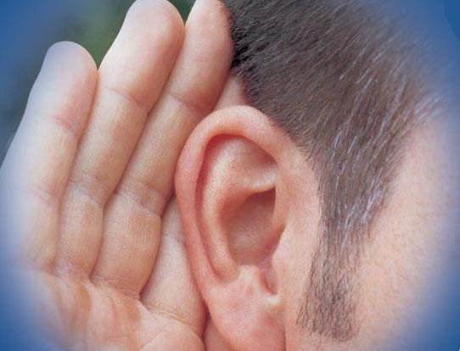
reverberated | A perfect fusillade of knocks reverberated through the house, and heard the scrapping of a chair as his wife put it down in the passage against the door. | (v.) resounded, reechoed | The teachers voice reverberated through the classroom. | 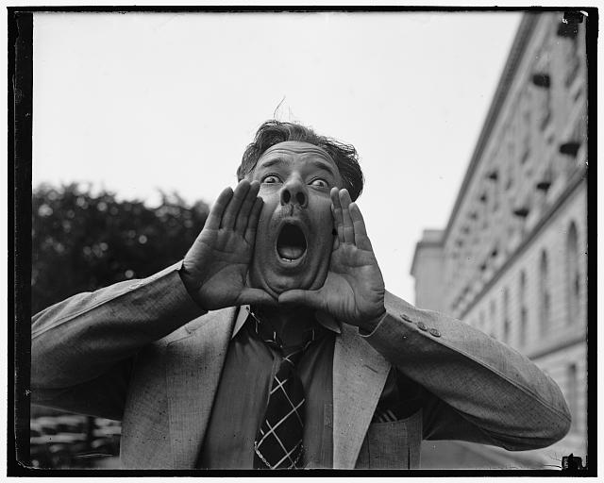

Comprehension Strategy

Before Reading : What is the strategy that you are using to help the child understand the text? These are some examples.
Make a connection | Make inferences | Prediction
Self Monitor | Prior Knowledge | Questioning
Identify Important Information | Visualize | Synthesis

Comprehension Strategy | Language ( What you say to support, teach the comprehension strategy)
Make a connection | Present students about “The Big Question:” Is there a difference between reality and truth? In “The Monkeys Paw,” a family learns the truth behind a mysterious monkey’s paw. Have student’s complete the following sentence:  People may verify the truth by_________________________________________________________.  Then review with students the underlined tier-2 words from the story and have them decide whether they know the word well, know it a little bit, or do not know it at all. After reading the story, have them explain how their knowledge of each word has increased.

During Reading : What is the strategy that you are using to help the child understand the text? These are some examples
Make a connection | Make inferences | Prediction
Self Monitor | Prior Knowledge | Questioning
Identify Important Information | Visualize | Synthesis

Page # | Comprehension or Vocabulary | Language you will use to teach, focus or probe for understanding
24-27 | Identify Important Information | Provide students with the note-taking guide/graphic organizer chart that they will use to record events that happen as a result of the White’s wishes.
23,27 | Prediction | What prediction, or guess can students make about the monkey’s paw and the White family. Have students circle details from the story that help make their prediction. Teacher should model this strategy first. At the end of the story have ask students, What predictions that you made were correct? What helped you make these correct predictions?
22-27 | Questioning | As the teacher and students are reading use reading checks/guiding questions to assess reading comprehension and elements of plot(listed in order of the story):  - What important background information(exposition) about the characters and their home is given in the first paragraph?  - Where has the sergeant major been for twenty-one years?  - The sergeant major tells the whites the history of the monkey’s paw. What part of the plot is this? (use the terms from the elements of plot to answer the question)  - What is the first wish Mr. White makes?  - What information does the stranger give to Mr. and Mrs. White?  - What is the second wish?  - How does the difference between what Mr. and Mrs. White are trying to do bring events to a climax?  - Who do you think is outside the White’s door?
p. 22  p. 27 | Fakir  fusillade | (n.) A very holy man (tier-3 word)  (n.) Rapid firing, as of gunshots (tier-3 word)

After Reading

Comprehension Questions
Bloom Taxonomy  Question Type | Question: Have a mix of questions
Knowledge | Who are the main characters in the story?  Where does the story take place?  What is special about the monkey’s paw?
Comprehension | How does each of the White’s react when first hearing the legend of the monkey’s paw?  How do the reactions of the mother and the father change?
Application | What lesson does the fakir want to teach? Does he succeed? Explain.
Analysis | Mr. White wishes for 200 pounds. What painful event seems to follow form his wish?
Synthesis | Sergeant Major Morris says the fakir warned that “fate ruled people’s lives, and that those who interfered with it did so to their sorrow.” Do the events of the story prove this point? Explain.
Evaluation | How does Mr. White word his first wish? Discuss the strengths and weaknesses of other ways the wish could have been worded. Decide whether any version is foolproof.

Culminating Writing Task

Teacher directions and activities to prepare students for writing:
Students will write a brief sequel to this tale in which someone else finds the paw. Students will answer the questions in the prompt to help them write their sequel.
Prompt:
Write a brief sequel to “The Monkey’s Paw” and tell what happens when someone else finds the paw. Use the following questions to help write your sequel:
- How does the new person get the monkeys paw?
- How will he or she learn about the history of the monkey’s paw?
- What does this person have, and what does he or she want?
- Will this person make a wish?
- What consequences will this person’s wishes bring?
Scoring notes or Sample response:
CATEGORY | 4 | 3 | 2 | 1
Focus on Assigned Topic | The entire story is related to the assigned topic and allows the reader to understand much more about the topic. | Most of the story is related to the assigned topic. The story wanders off at one point, but the reader can still learn something about the topic. | Some of the story is related to the assigned topic, but a reader does not learn much about the topic. | No attempt has been made to relate the story to the assigned topic.
Organization | The story is very well organized. One idea or scene follows another in a logical sequence with clear transitions. | The story is pretty well organized. One idea or scene may seem out of place. Clear transitions are used. | The story is a little hard to follow. The transitions are sometimes not clear. | Ideas and scenes seem to be randomly arranged.
Problem/Conflict | It is very easy for the reader to understand the problem the main characters face and why it is a problem. | It is fairly easy for the reader to understand the problem the main characters face and why it is a problem. | It is fairly easy for the reader to understand the problem the main characters face but it is not clear why it is a problem. | It is not clear what problem the main characters face.
Spelling and Punctuation | There are no spelling or punctuation errors in the final draft. Character and place names that the author invented are spelled consistently throughout. | There is one spelling or punctuation error in the final draft. | There are 2-3 spelling and punctuation errors in the final draft. | The final draft has more than 3 spelling and punctuation errors.

Differentiation Options (modify by content, process, and/or final product)

English Language Learners (ELL) | - While reading have students listen to portions of the selection on the Hear It! Audio CD  - If needed allow students to answer questions verbally and teacher can write them on white board for students to copy.  - While reading have students circle unfamiliar words.  - Students may have difficulty understanding the role exposition plays in plot. Use the completes Plot Diagram to explain to students how the information given in the beginning of the story establishes the background for the plot.  - Pair ELL with a non-ELL partner  - Extended time
Language learner disabilities | - While reading have students listen to portions of the selection on the Hear It! Audio CD  - If needed allow students to answer questions verbally and teacher can write them on white board for students to copy.  - While reading have students circle unfamiliar words for teacher to  - Students may have difficulty understanding the role exposition plays in plot. Use the completes Plot Diagram to explain to students how the information given in the beginning of the story establishes the background for the plot.  - Extended time

Any visuals or other supporting documents that you feel support this lesson.

After reading have students watch “The Monkey’s Paw” (2011) 29:44 on YouTube.com

