Lesson Template

Title and Author:
A Hat for Mrs. Goldman by Michelle Edwards
Grade: 1

Reading Level: 2.7 | Lexile Level: 520L
Key Understanding: Kindness and being considerate of others are two valued character traits. When we find a task to be difficult we need to keep trying and use creativity to overcome the challenge.

Suggested number of days: __3______Common Core ELA Standards:
CCSS.ELA-LITERACY.RL.1.1 Ask and answer questions about key details in a text.
CCSS.ELA-LITERACY.RL.1.6 Identify who is telling the story at various points in a text.
CCSS.ELA-LITERACY.L.1.5.C Identify real-life connections between words and their use.

IEP Goals lesson addresses
CCSS ELA-Literacy SL. K. 2

By June Nuala will increase her literacy skills as evidenced by her ability to retell a story in sequence ( beginning, middle and end) with 80% accuracy across 3 different stories.

Baselines: If scores are not available to you create a sample score that a student might have.
Student | Vocabulary | Story Grammar/Comprehension | Written Language
SAMPLE CHILD | SS 75 on PPVT | Can name characters  Listening comprehension | SS 70 below grade level
N G | Montgomery Assessment of Vocabulary Acquistion (MAVA)  Tier One Vocabulary 98%  Tier Two Vocabulary 28% | Clinical Evaluation of Language Fundamentals  CELF-5  Understanding Spoken Paragraphs SS 6 (average is 10)  Sentence Comprehension SS6 (average is 10) | needs continued intervention in the area of writing. N needs teacher support and a visual letter line in order for her to write with accurate letter sound correspondence. When planning on the sentence she is writing, the teacher provides lines for each word while she is writing in order for her to appropriate space out her words while she is writing. N needs continued reminders in differentiating between letters, words, and sentences.

Materials:

Book, slide show for vocabulary, knitting needles, yarn

Before Reading
Cultural Supports, Building Background
Discuss and introduce words from Judaism featured in book; mitzvah and
Show knitting materials and short video on how to knit
Discuss neighbors and times we’ve done things for our neighbors

Connecting Activity: (Questions, Conversation about topic):
Do you know anything about being Jewish or anyone that is Jewish?
Do you know anyone that likes to knit?
Have you ever made something for another person as a gift? How did that feel?
Have you ever had to complete something that was challenging?

Genre Set-Up, Bridging Conversation, Think-Aloud, Setting Purpose
(What strategy are you highlighting in your lesson)
In order to understand the lesson of the story we will preview the text and discuss how it feels to make things for others/give gifts. We will also discuss the importance of not giving up.

Vocabulary
Word | Contextualize Word  In the story….. | Definition  ( kid friendly) | Example beyond story | Bridge to story  Picture
Knit | Both characters knit in the story | To make a piece of clothing by tying yarn together using needles. | I will knit this scarf. (Show scarf) | 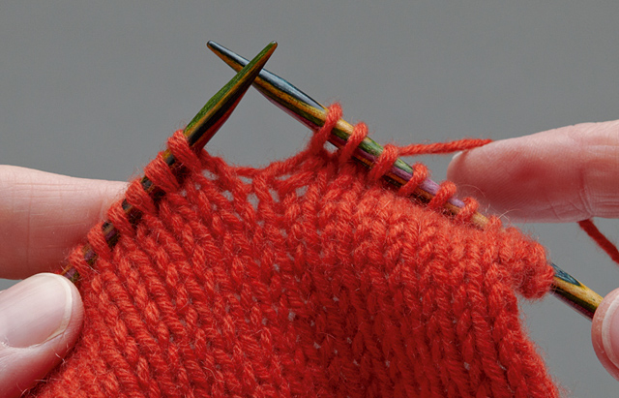
Fierce | The wind is fierce and makes Mrs. Goldman cold. | Something that is very strong. | A lion’s roar is very strong or fierce. | 
Fret | Sophia is very worried that Mrs. Goldman’s head is cold. | To worry about something. | You worry or fret that you will be late for school. | 
Bundle | Sophia bundles her yarn together. | To put or tie many things together into a pile. | You bundle your hair into a ponytail and tie it with a hair tie. | 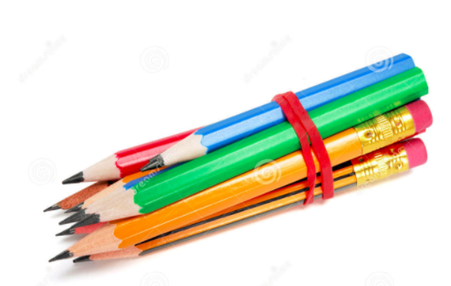
Exclaim | Mrs. Goldman exclaims when Sophia gives her the hat. | To talk in an excited way. | You exclaim “Happy birthday!” | 

Comprehension Strategy

Before Reading : What is the strategy that you are using to help the child understand the text? These are some examples.
Make a connection | Make inferences | Prediction
Self Monitor | Prior Knowledge | Questioning
Identify Important Information | Visualize | Synthesis

Comprehension Strategy | Language ( What you say to support, teach the comprehension strategy)
Make a Connection | When is a time that you made something for another person?  How does it feel to give a gift?  How does it feel to receive a gift?  Do you know your neighbors? Are you close with any of them?

During Reading : What is the strategy that you are using to help the child understand the text? These are some examples
Make a connection | Make inferences | Prediction
Self Monitor | Prior Knowledge | Questioning
Identify Important Information | Visualize | Synthesis

Page # | Comprehension or Vocabulary | Language you will use to teach, focus or probe for understanding
1 | Knit | Do you remember what knitting is? (If not bring up slide show to remind)
2 | Keppies | “A keppie is Jewish word for our head.” Repeat back what it means. Display vocabulary card.
2 | Mitzvah | “A Mitzvah is a Jewish word for a good deed.” Repeat back what it means. What is a good deed?  When I know she understands a good deed move on.
4 | Bundle | What is a bundle? (If having trouble answering bring up slide show)
5 | Why is Sophia worried? | Mrs. Goldman’s hair is blowing and her ears are pink. She gave her hat to Mrs. Chen. How is that a good deed? What does that say about Mrs. Goldman?  How does Sophia feel about Mrs. Goldman not having a hat?
7 | How does Sophia feel about knitting? | Expected response: It is hard.
8 | What do you think Sophia will do with the yarn? | Child can reply as she wishes. A great reply would be “Make something with the yarn” or “Make a hat for Mrs. Goldman”
10 | Fret | What does fret mean?
12 | Fierce | What does fierce mean?
14 | Why is Sophia knitting so much? | Expected response: “She wants to make a hat quickly for Mrs. Goldman.”
17 | What do you predict Sophia will do? | Expected response: “Try to make a new hat.” Or “Give up” or “Give it to her anyway.”
18 | Abuela | Abuela means grandmother in Spanish.
19 | Use the picture on the page to predict how Sophia will fix the hat. | Expected response: “There are pom-poms all over the page, maybe she will use those.”
26 | Exclaim | What does exclaim mean?
26 | How does Mrs. Goldman feel when she gets the hat? | She is happy. She feels good
27 | How does Sophia feel when she gives Mrs. Goldman the hat? | She is also happy and proud of her work.

After Reading

Comprehension Questions

Bloom Taxonomy  Question Type | Question: Have a mix of questions
Knowledge | Why did Sophia want to knit a hat for Mrs. Goldman?
Comprehension | Can you retell the story for me in your own words?
Application | How is Sophia an example of overcoming a challenge?
Analysis | How are Sophia and Mrs. Goldman different?
Synthesis | What could have been a different solution to fixing the hat?
Evaluation | What was the most important part of the book?

Culminating Writing Task

Teacher directions and activities to prepare students for writing
Show pages from book as teacher talks:
In this book the girl faced a challenge when she was knitting a hat.
Instead of giving up, she was creative and fixed the hat using creativity.
Because she did not give up she was able to give Mrs. Goldman a hat!

Prompt: Draw a picture of a time you had trouble completing something or making something. Then write one or two sentences about that time.
Scoring notes or Sample response:
To receive a perfect score:
Sentence(s) has punctuation at the end.
Sentence(s) matches the picture.
Sentence(s) describes a challenge.

Sample Response:
I was learning to swim and almost gave up but kept trying.
I was doing math that was hard. I finished it.

Differentiation Options (modify by content, process, and/or final product)

English Language Learners (ELL) | Use slide-show with visuals for every tier 2 and 3 vocabulary word. Refer back to visuals when reading the new words in the book.  Provide audio version of book to listen to ahead of time.  Print out questions that will be asked.  Translate key words in the questions into native language if possible.  Emphasize pictures that depict the sentences in the book.
Language learner disabilities | Use slide-show with visuals for every tier 2 and 3 vocabulary word. Refer back to visuals when reading the new words in the book.  Blend and chunk sounds.  Re-read the book with teacher or peer.  Act out the main events.

Any visuals or other supporting documents that you feel support this lesson.

